If you plan on doing a lot of hardware build, it would make life a lot easier if you purchase a cabinet of sort, this like to organize all the components.

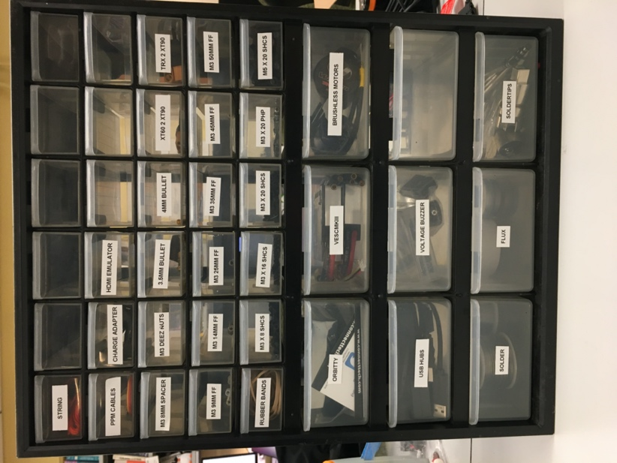

There are three main sections on the vehicle.

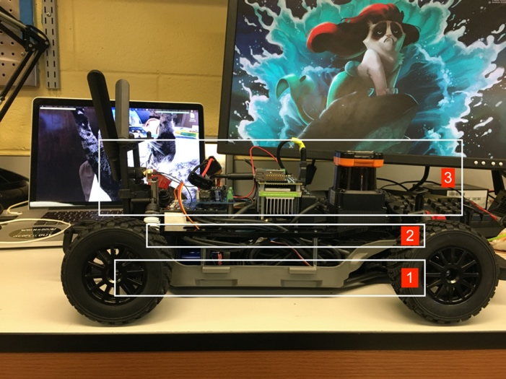

For clarity in this build documentation

[1] will be referred to as the “lower level chassis”

[2] will be referred to as the “upper level chassis”

[3] will be referred to as the “autonomy elements”

1. SETTING UP THE LOWER LEVEL CHASSIS

We begin with setting up the lower level chassis, which serves as the foundation of the entire vehicle. Take the traxxis from its box and remove the outer shell so you are left with just this:

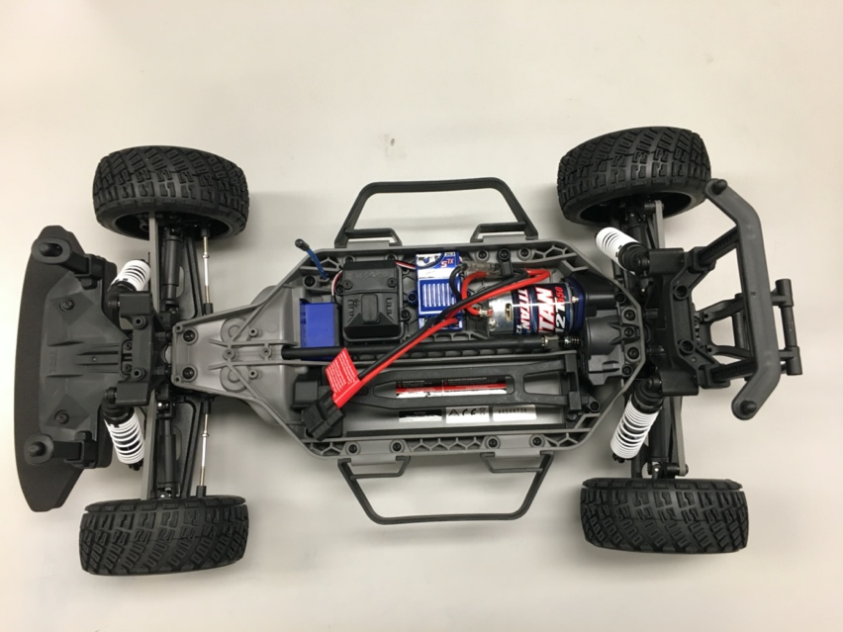

We are going to remove everything except for the servo, which is the little blue box in the upper left. There are three hex keys that come with the traxxas. You will use this to remove and/or install almost all of the screws on the chassis. You may want to have a bowl or container of sorts nearby to hold all the screws that you’ll be removing as these screws will come in handy later.

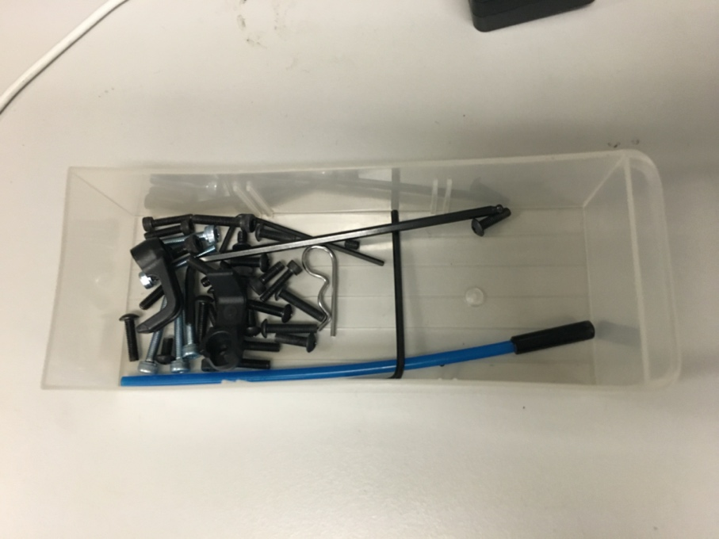

Remove the servo box by first unscrewing the lid.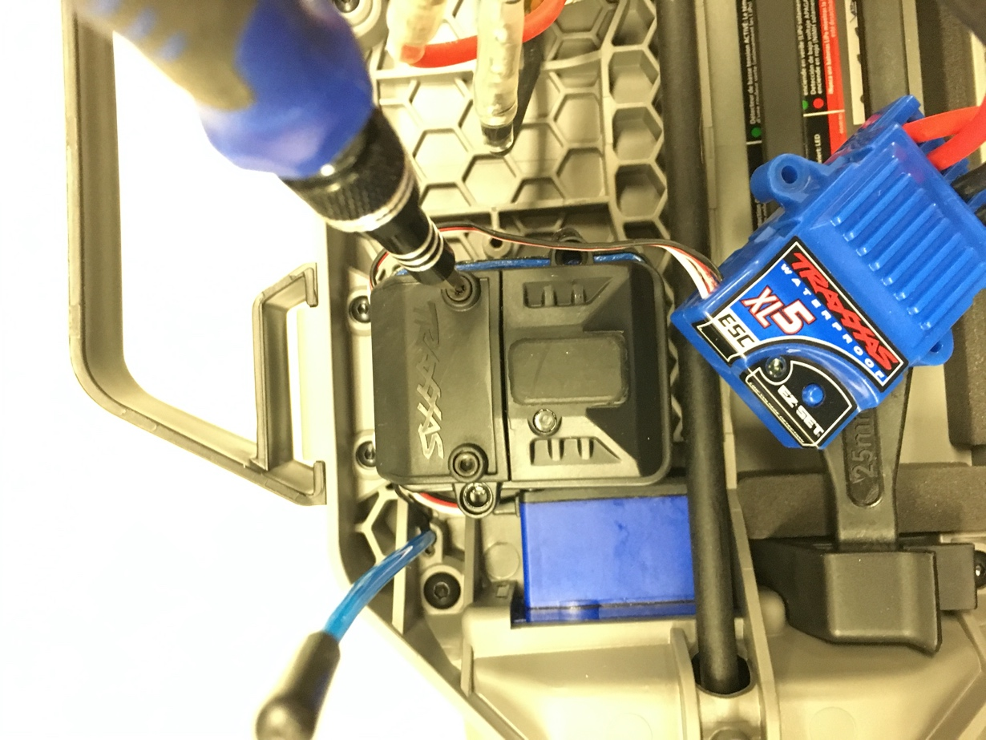

Once the top is open, use a screwdriver to pry the black box below out. There are screws beneath it that we have to access in order to completely remove the ESC box.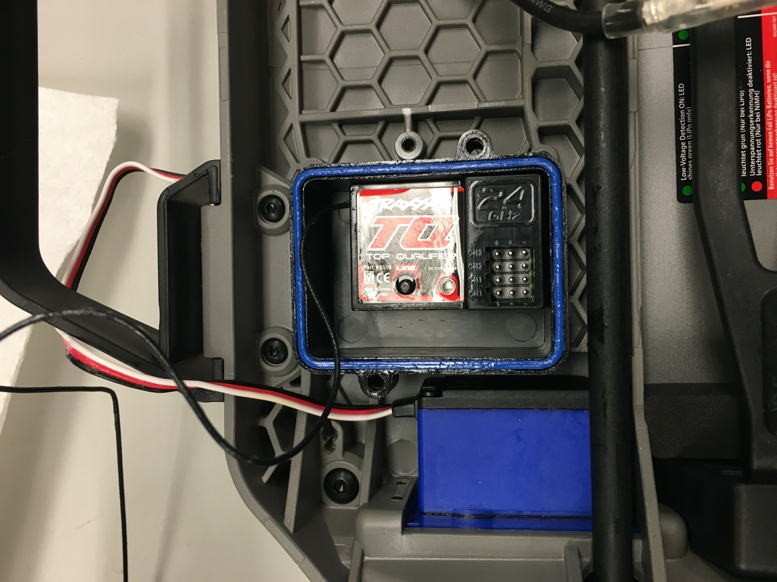

Once the ESC has been removed, you will see the two screws underneath. Unscrew these and then you’ll be able to remove the box.



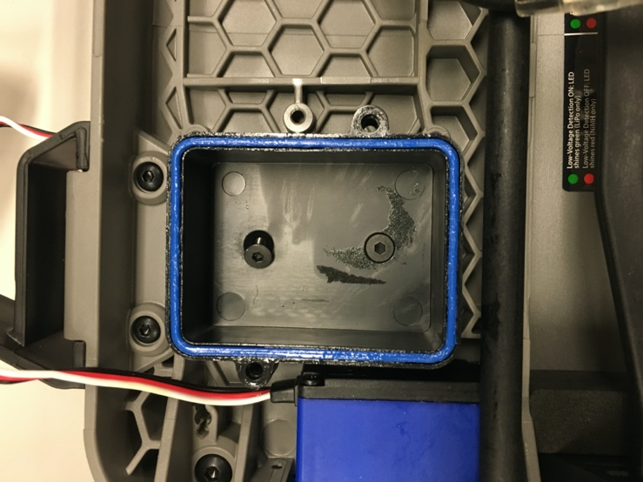

Remove the motor and the rest of the other components so that your final lower level chassis looks like the following:

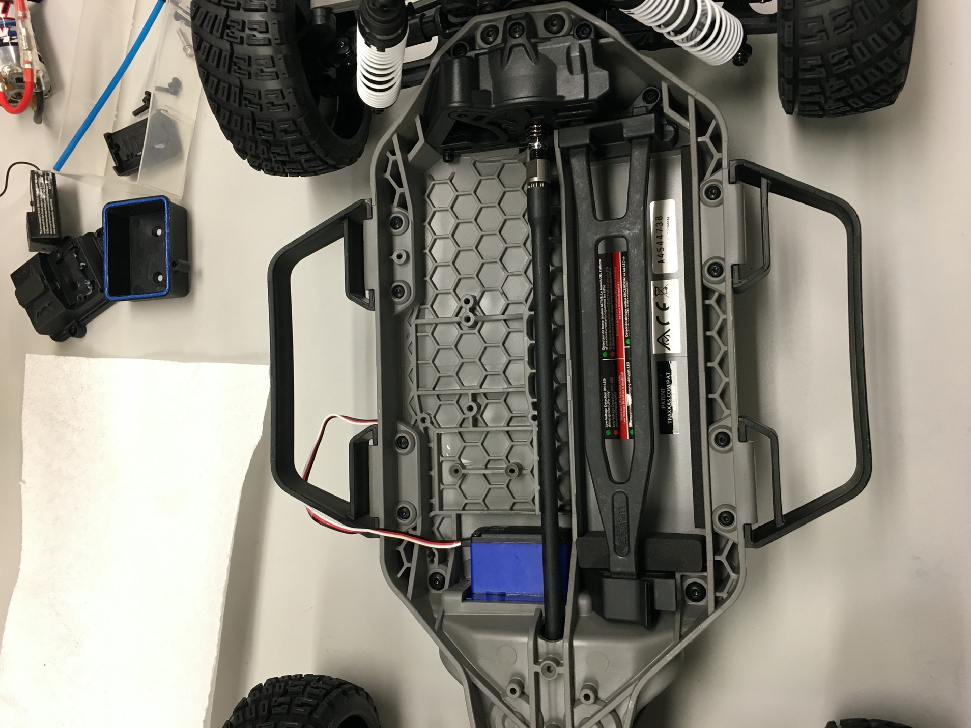

You’ll also need to remove the plastic fork out as well.

Installing the brushless motor:

To install the brushless motor, first remove the blue plate and the spur gear connected to the brushed motor.

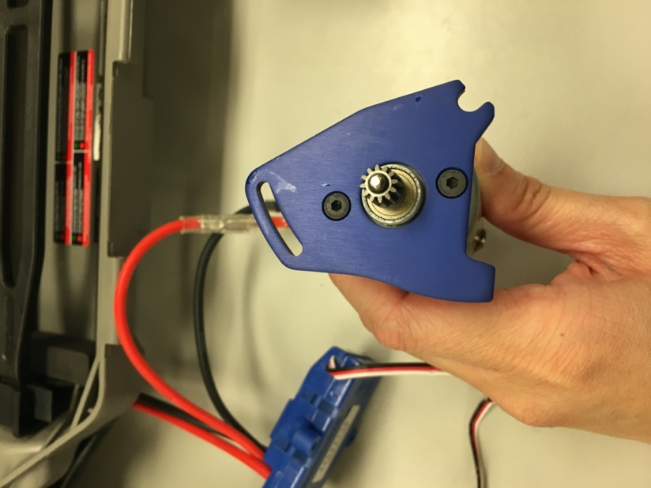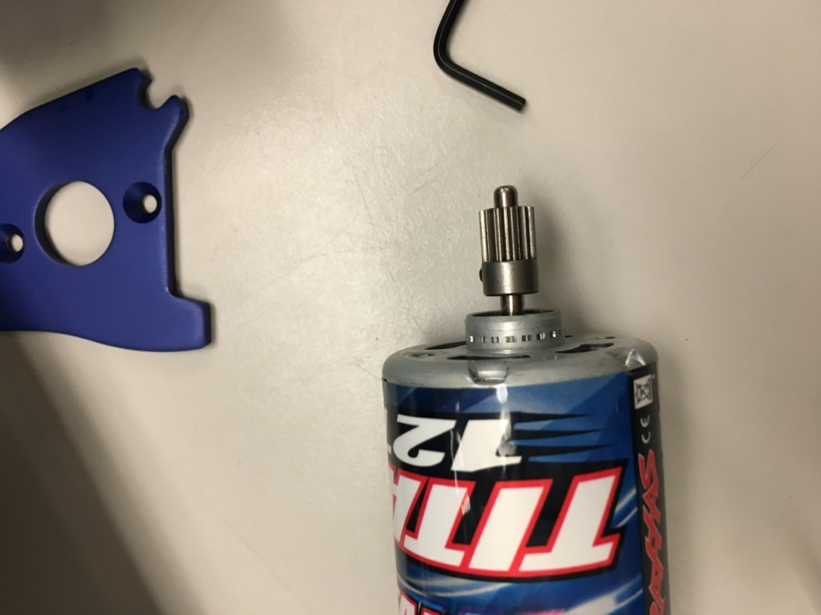

Install the blue plate and spur gear onto the brushed motor so your brushed motor now looks like this:

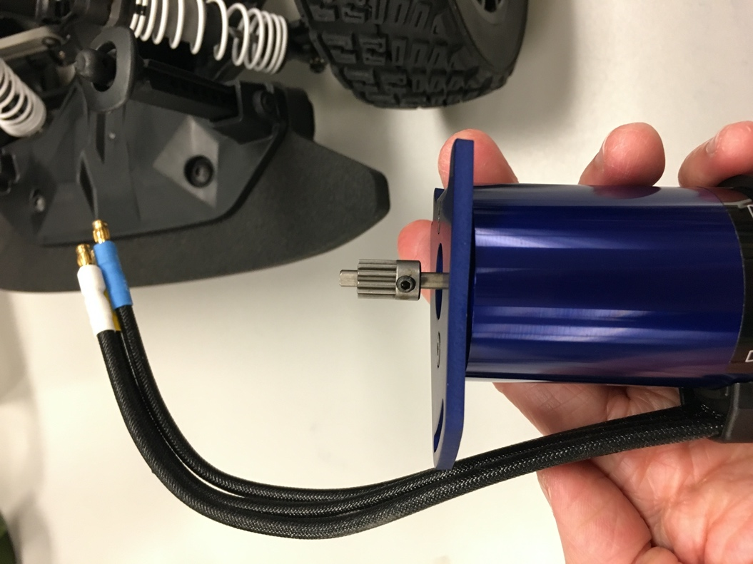

We have to align the spur gear with the rest of the gears on the lower level chassis. Remove the gear casing so you can see if the gears align or not.

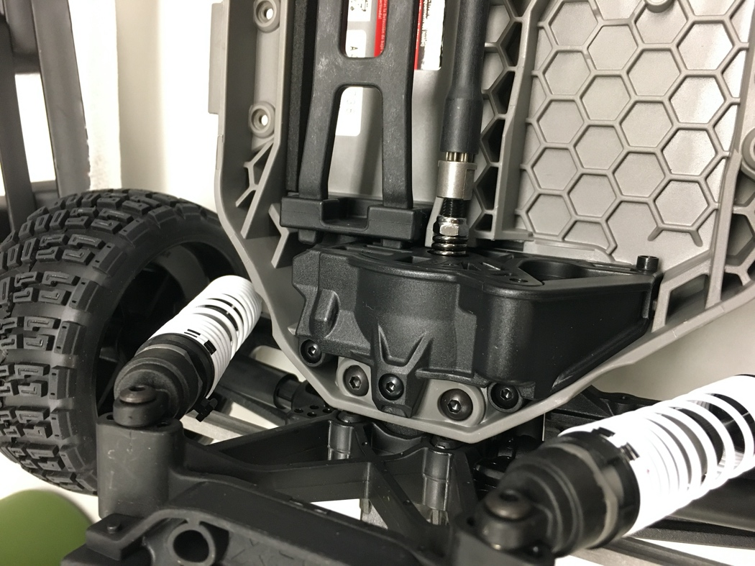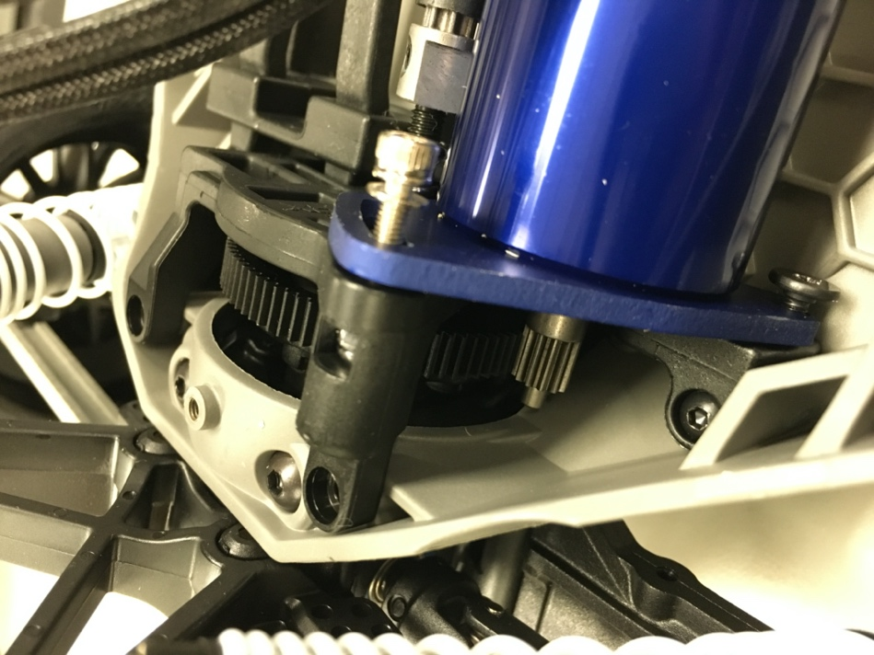

Adjust the position of the spur gear accordingly so that when you move the car back and forth on the table, the movement feels smooth and you can see the gears mesh and move without slipping or skipping teeth. Replace the covering once you are satisfied.

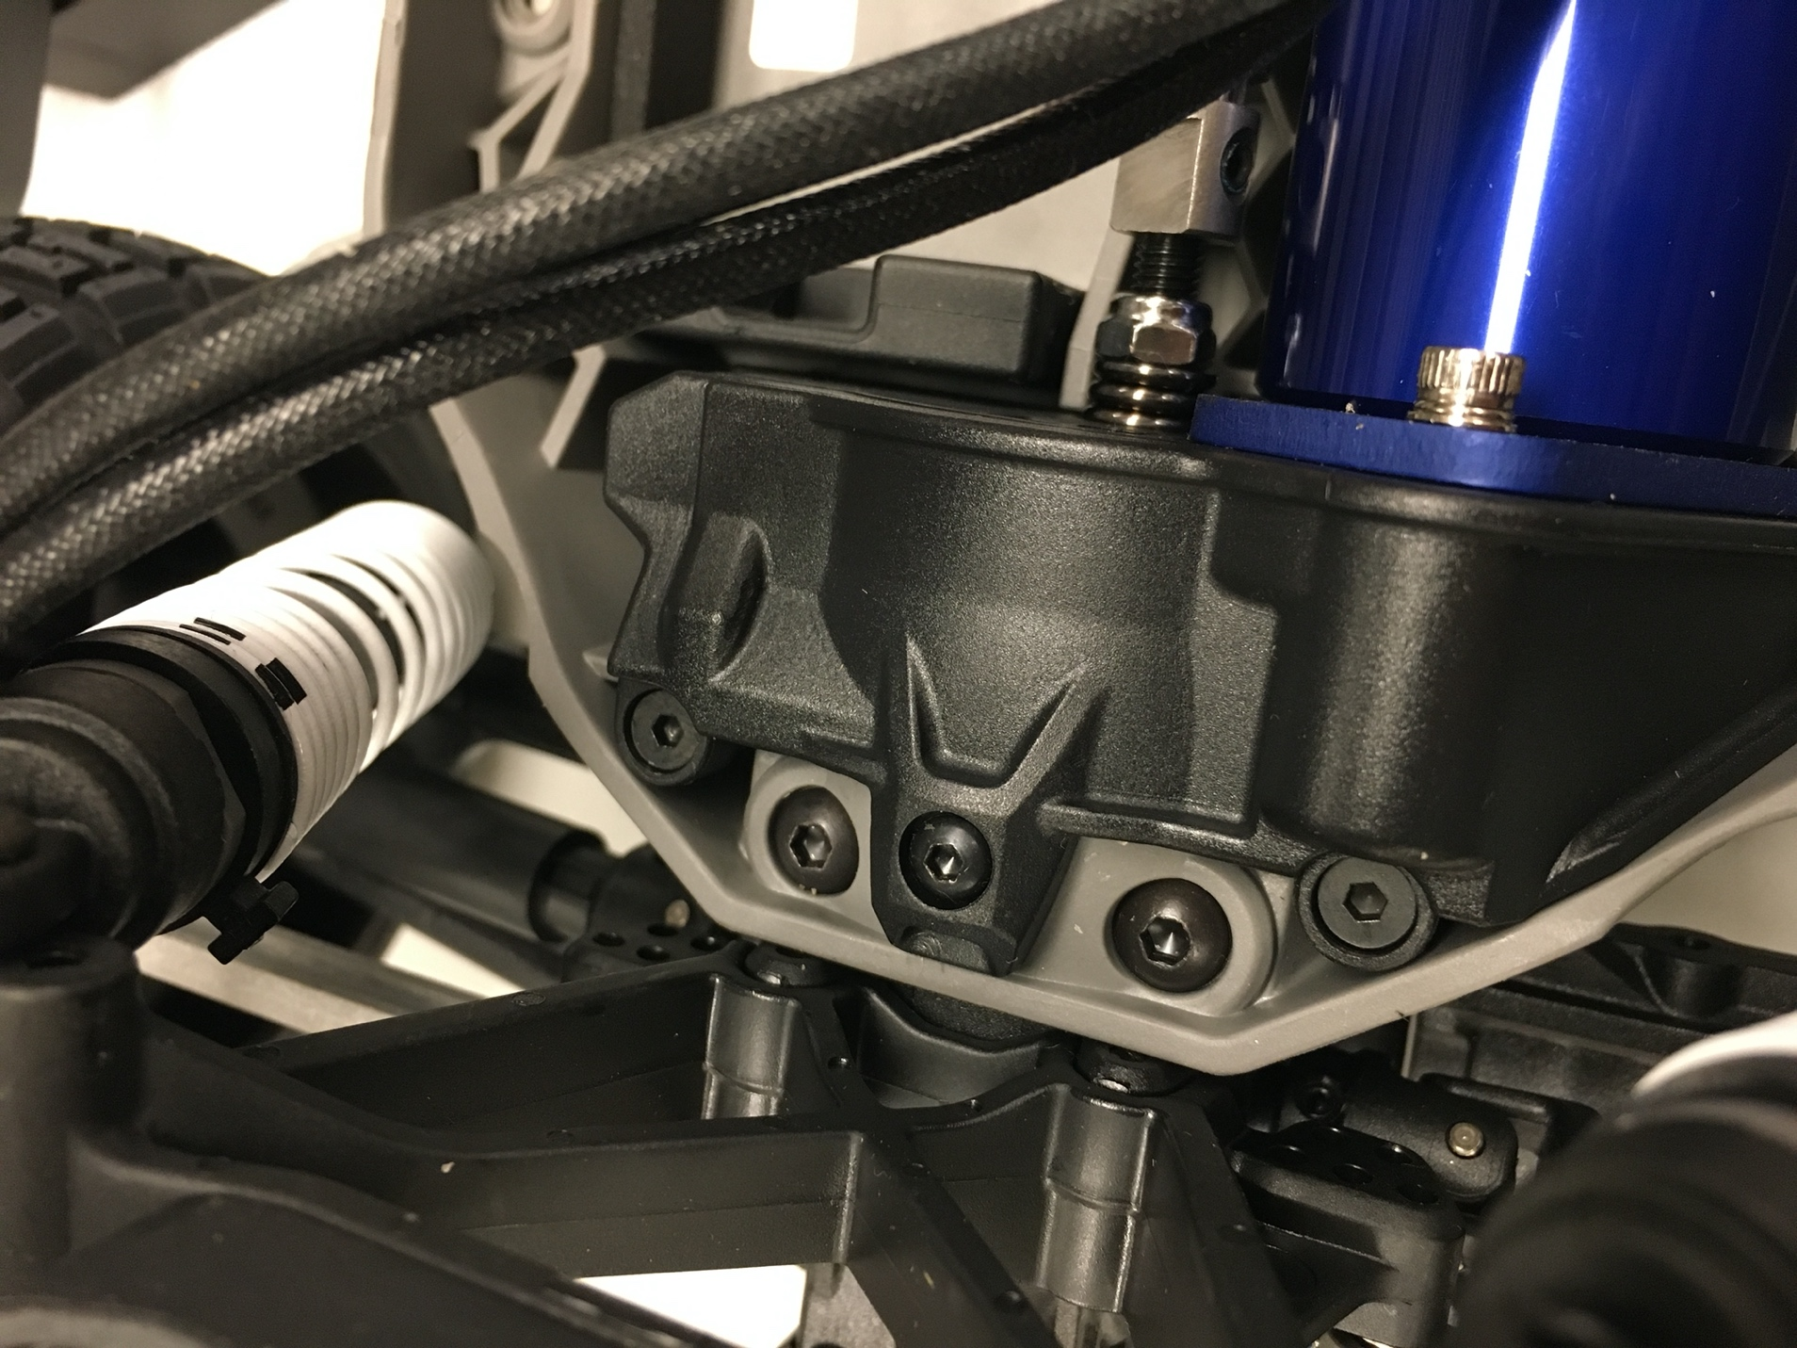

Once the brushless motor has been installed, the final lower level chassis should look like this:

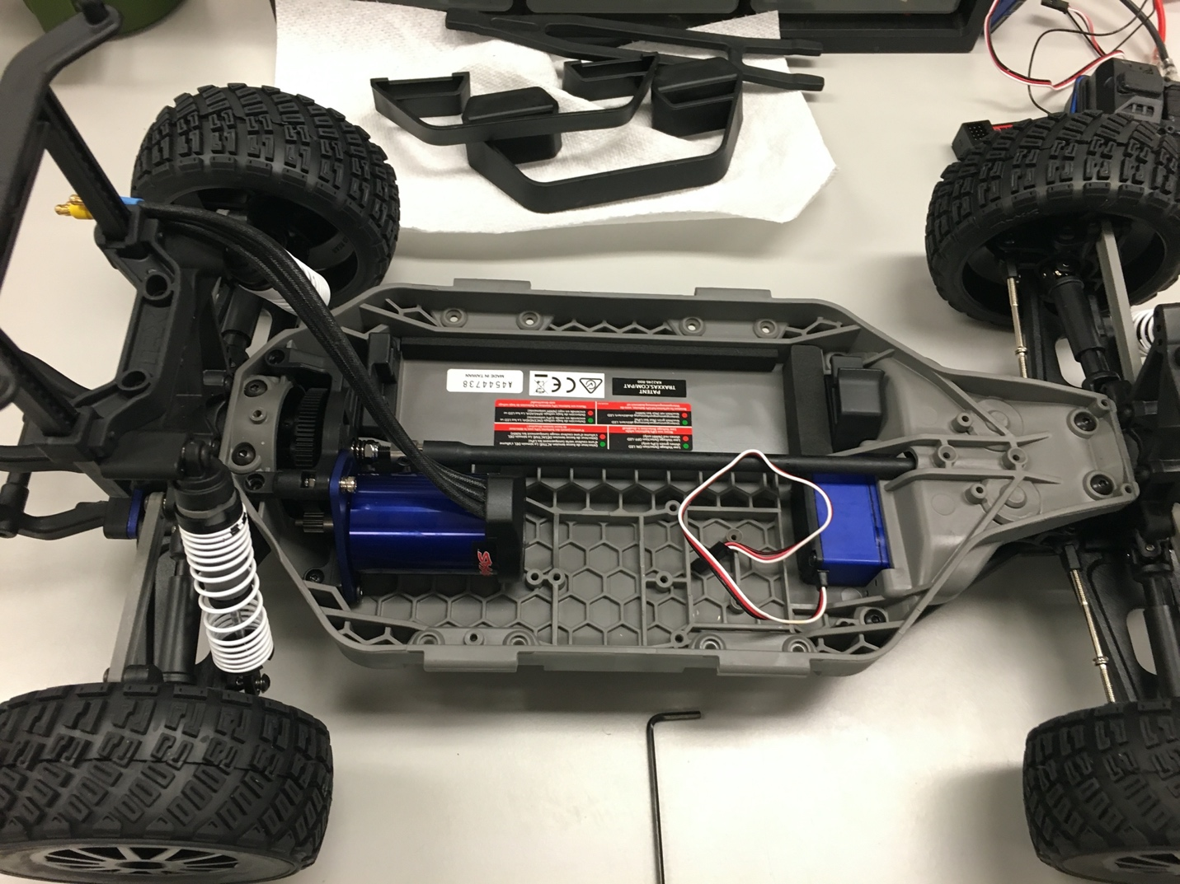

Install three M3 screws and three 45mm M3 FF standoffs into the lower chassis:

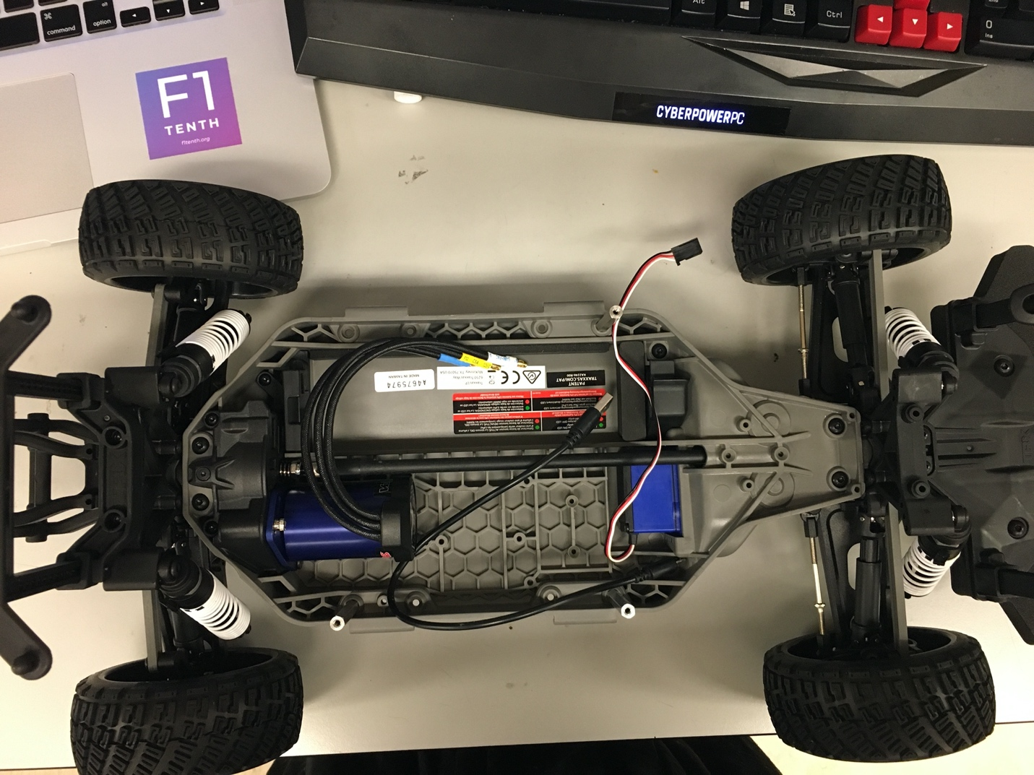

We only install three standoffs to increase ease of battery removal.

Place the battery into the compartment opposite of the motor.

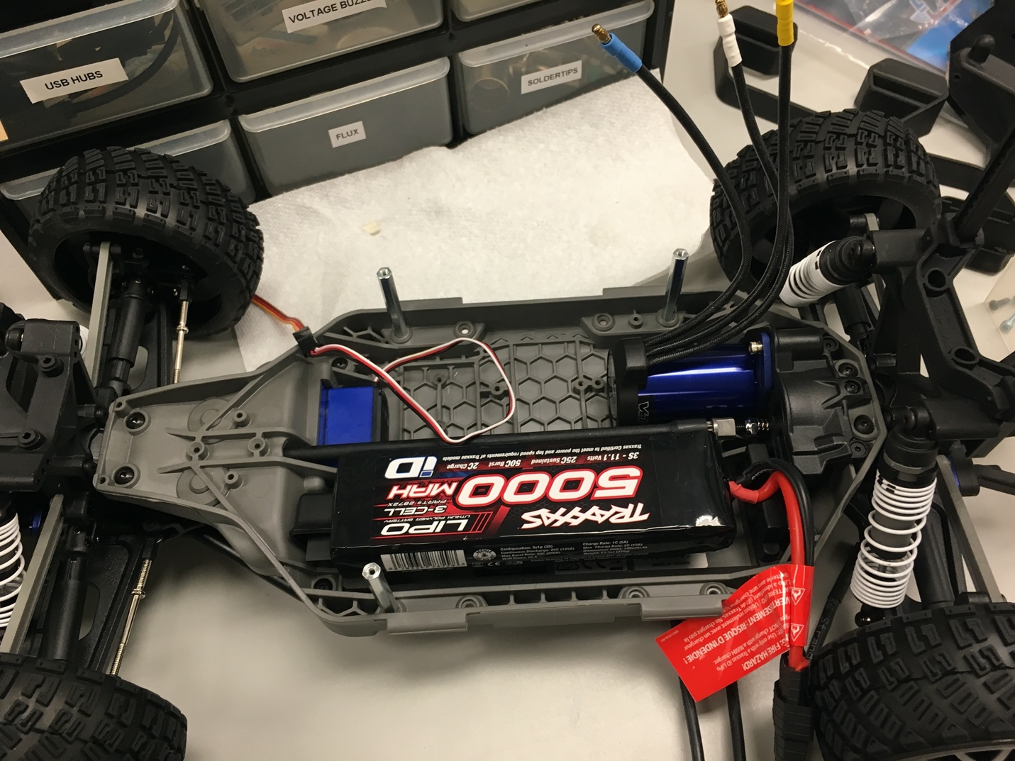

Plug the charge adapter into the battery plug,

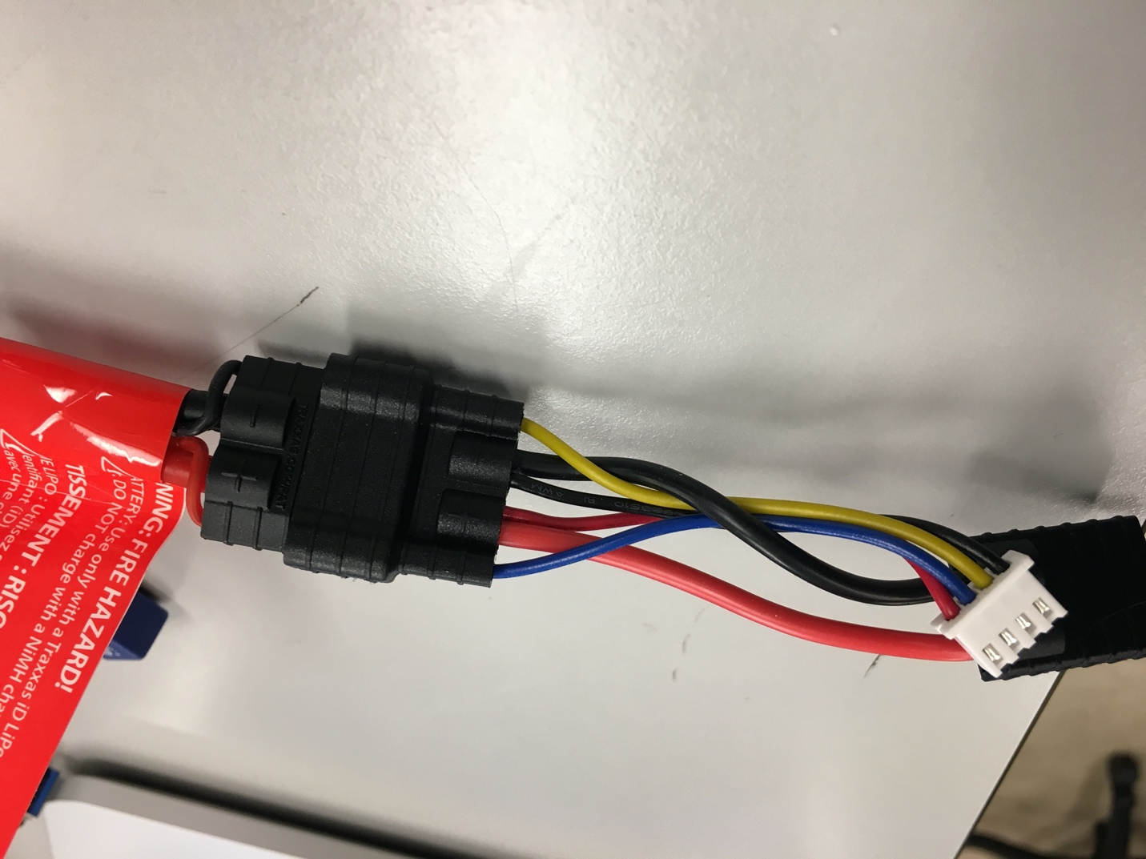

Then, connect the other side of the charge adapter to a TRX to XT90 cable.

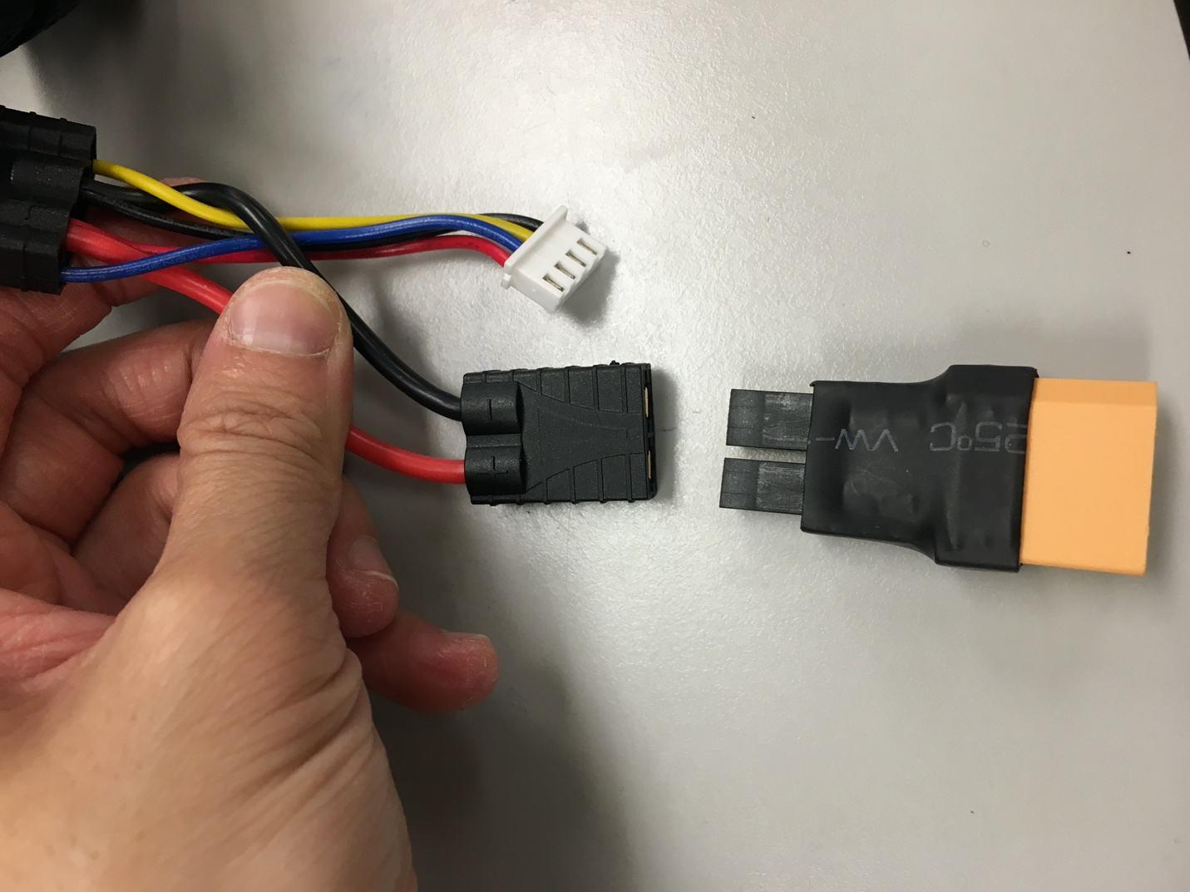

It should look like this:

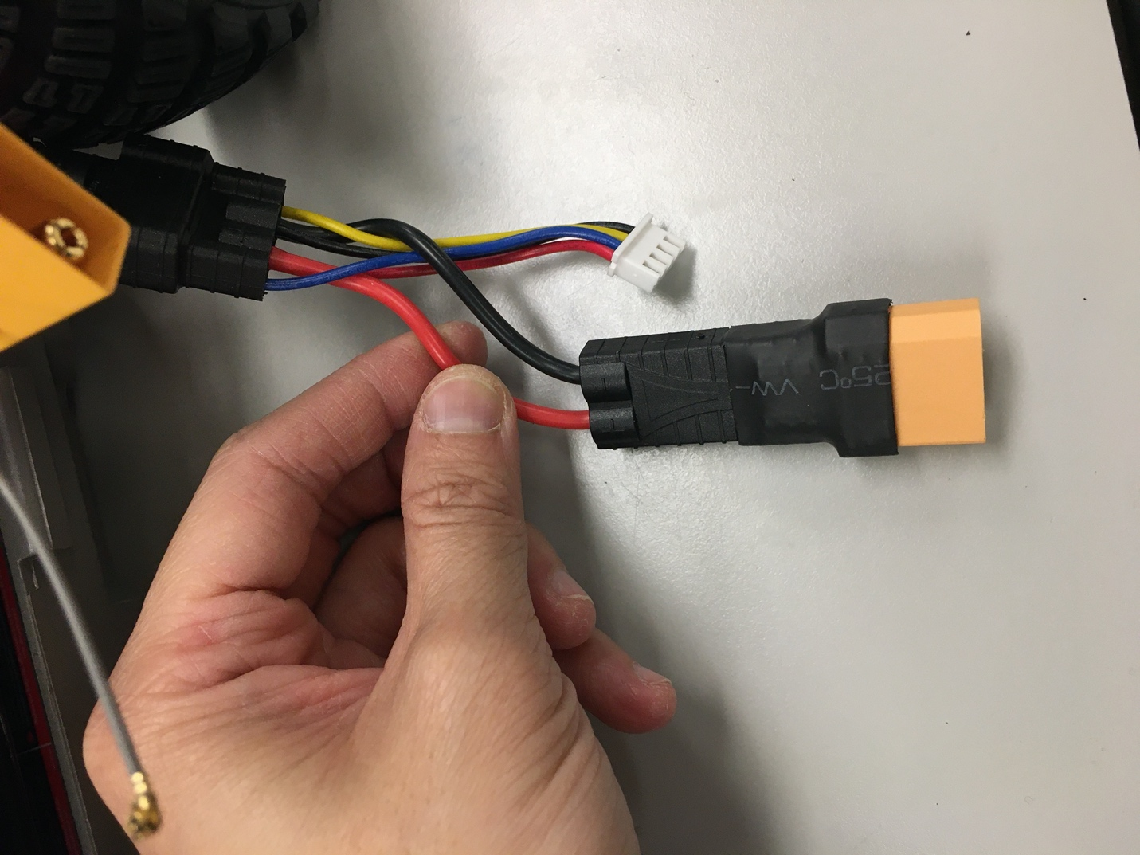

Take 3 header pins

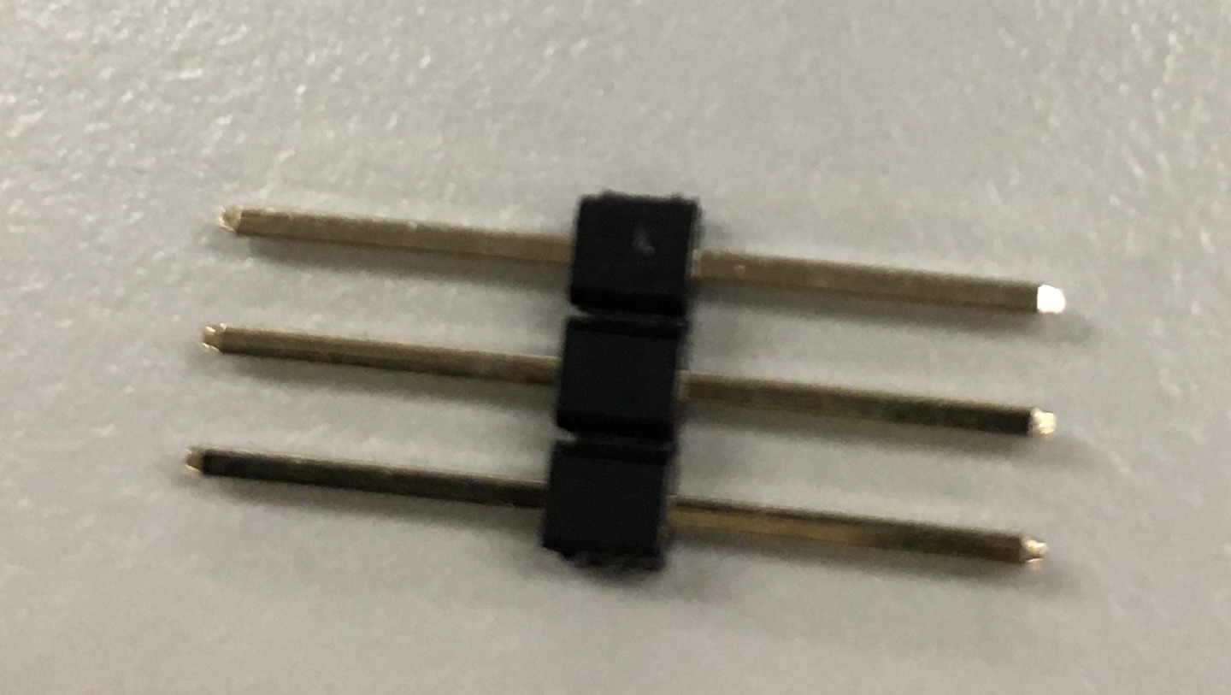

And connect the ppm cable with the servo wire.

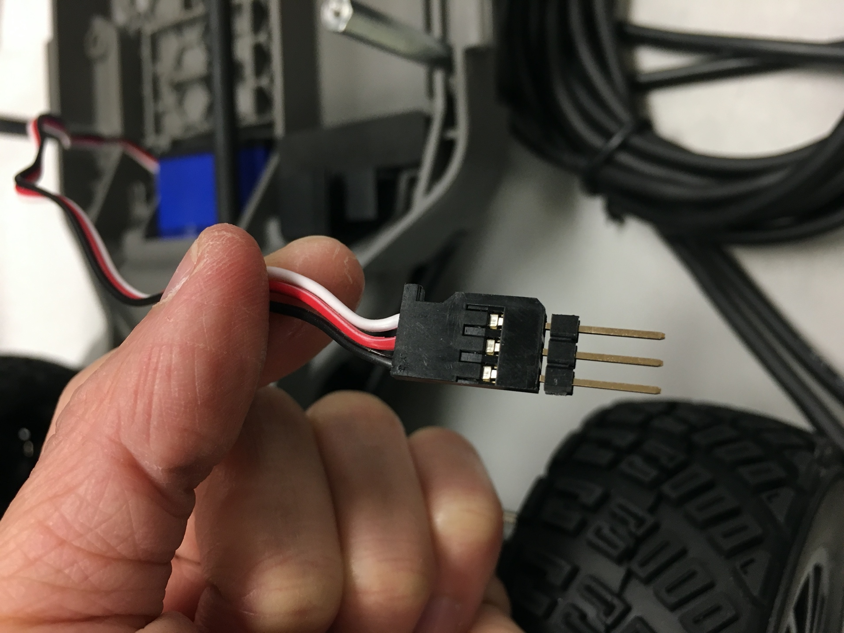

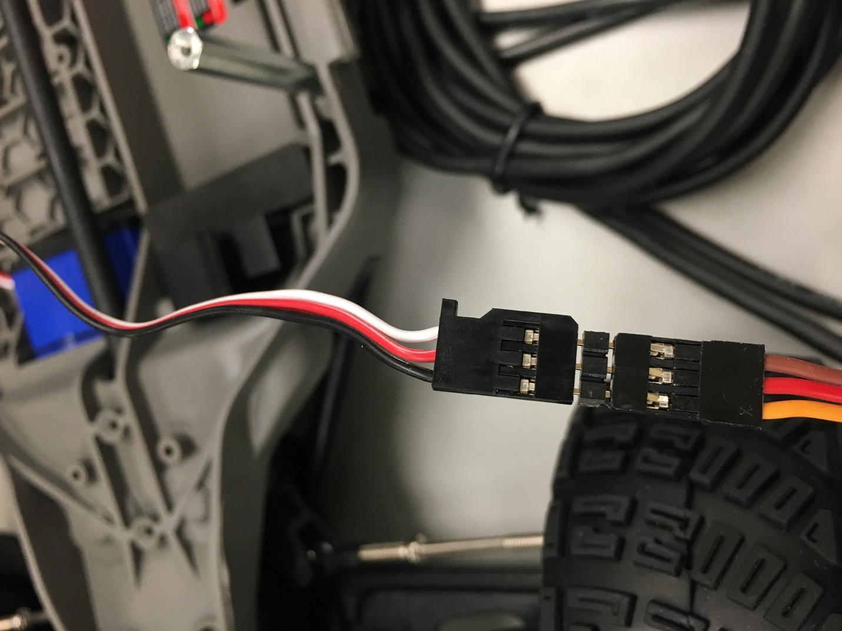

1. Autonomy Elements

Place the Orbitty Carrier board on top of the TX2 like so:

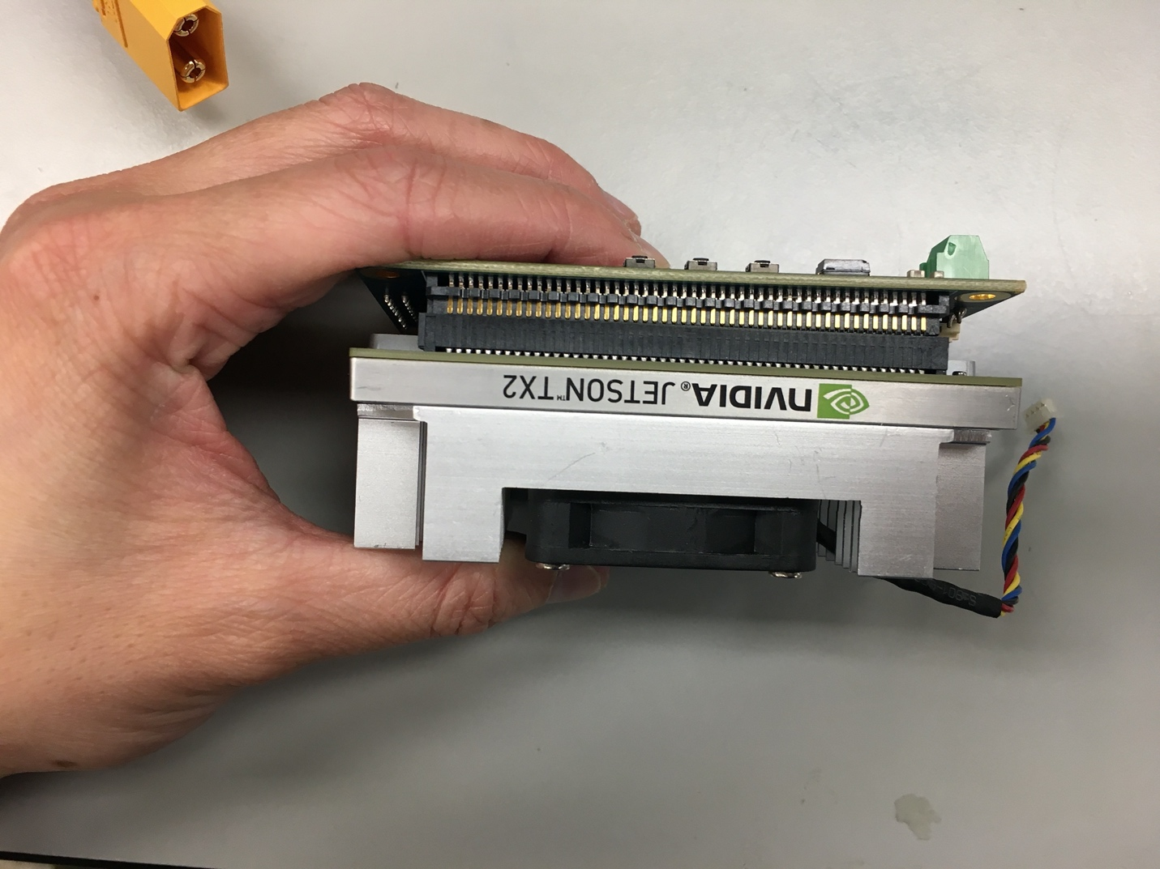

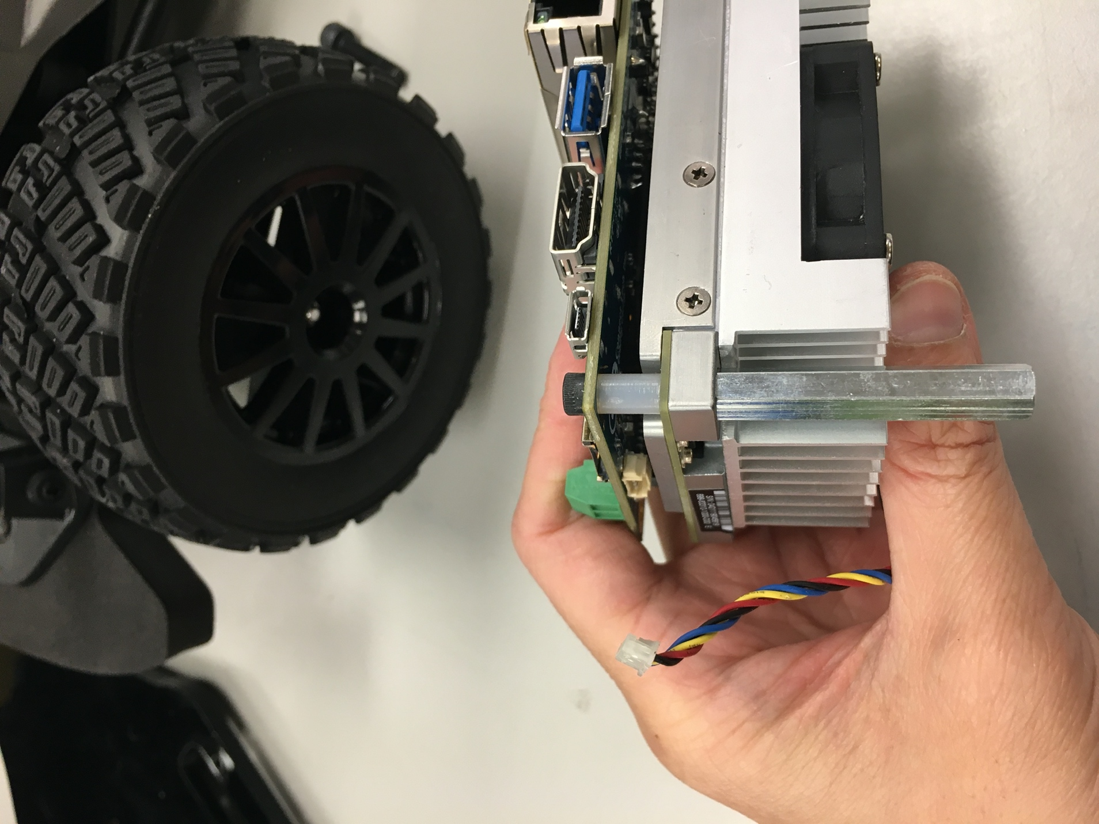

Put an M3 x 20mm screw through one of the orbitty mount holes followed by one 8mm nylon spacer then 35mm FF M3 standoffs. Repeat for the remaining three mounting holes.

The results should look like this:

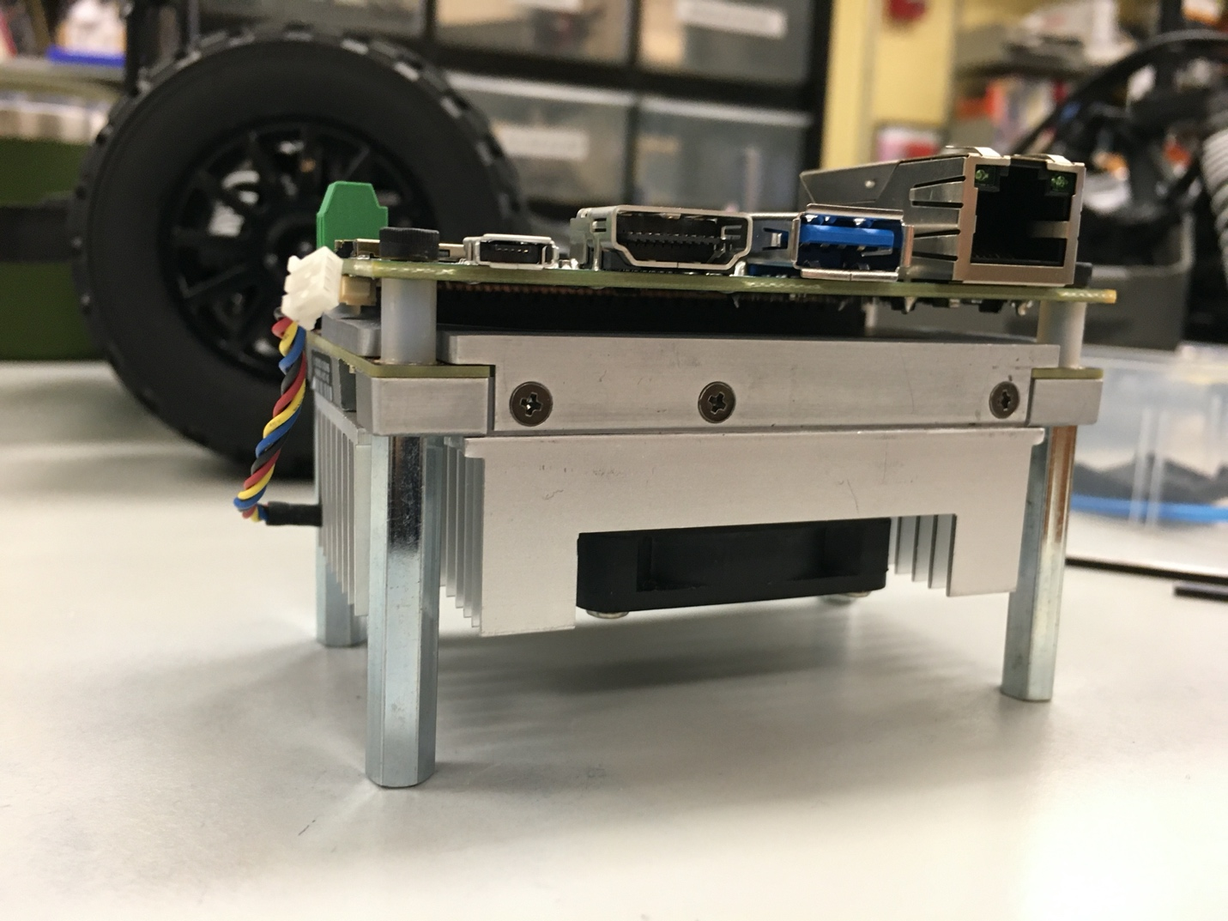

Make sure to also plug the TX2 into the orbitty.

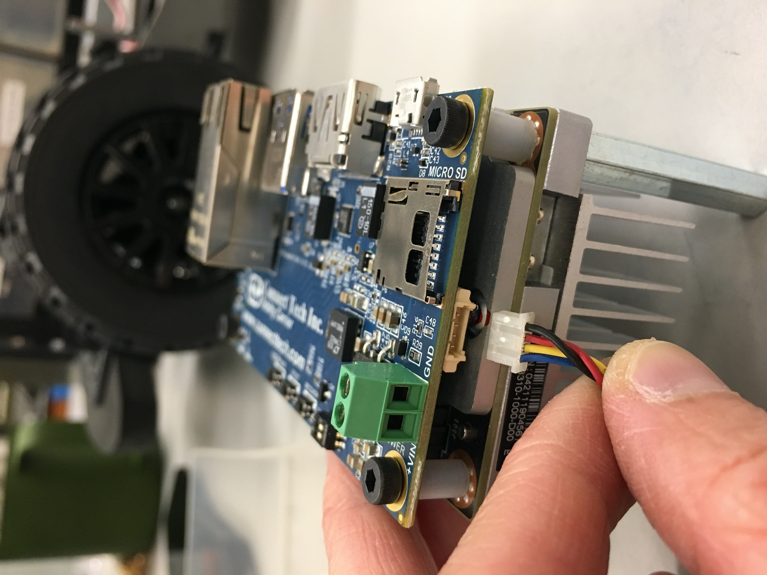

1. Upper level Chassis

Now we’re going to assemble the upper level chassis.

Place the laser cut piece so it’s facing you like this. The laser cut piece will be referred to as the acrylic.

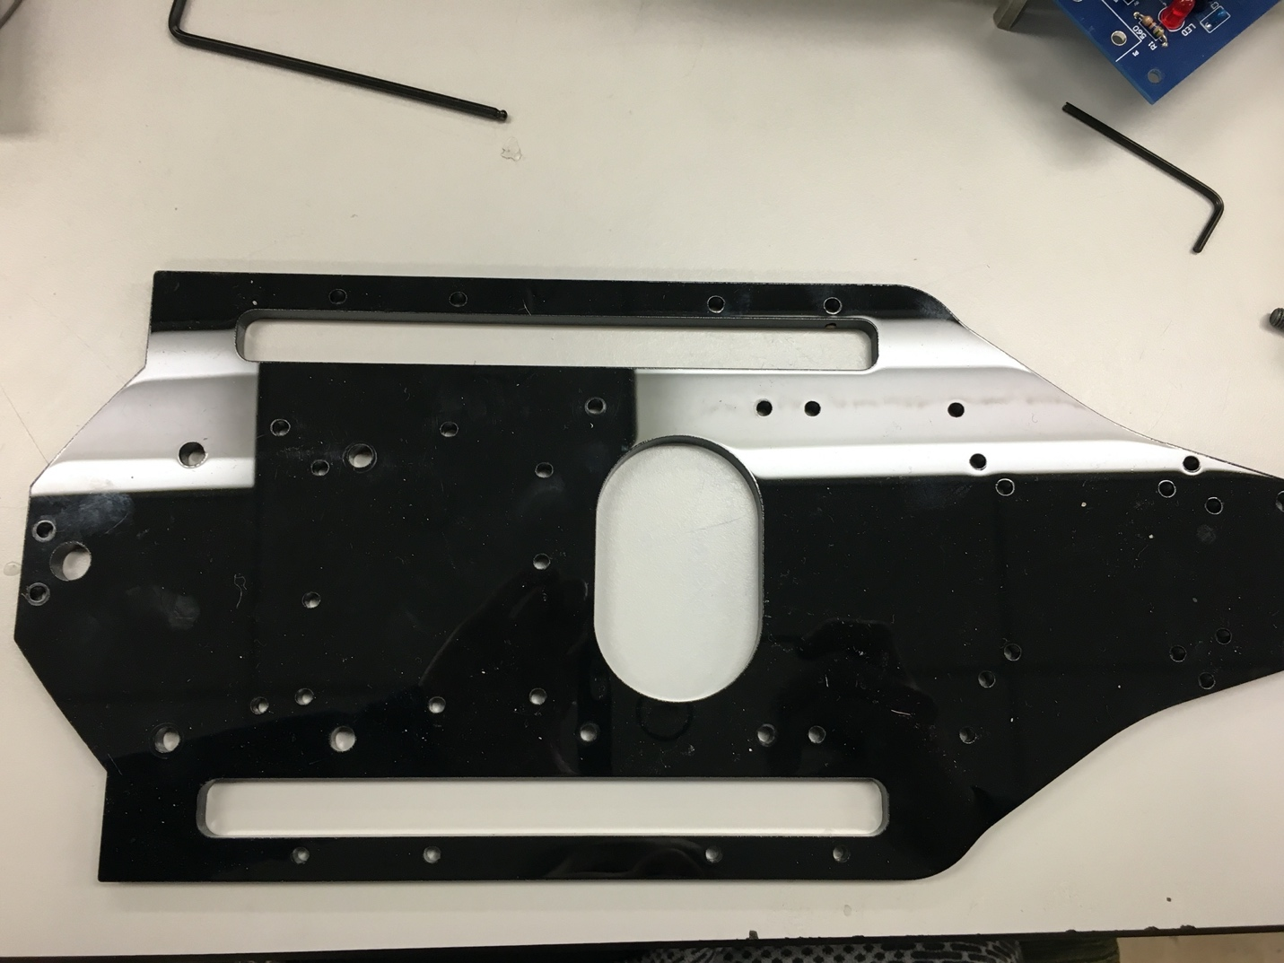

This piece is not symmetric. Note that the big M5 mounting holes on the left are not centered. The holes need to be skewed closer to you.

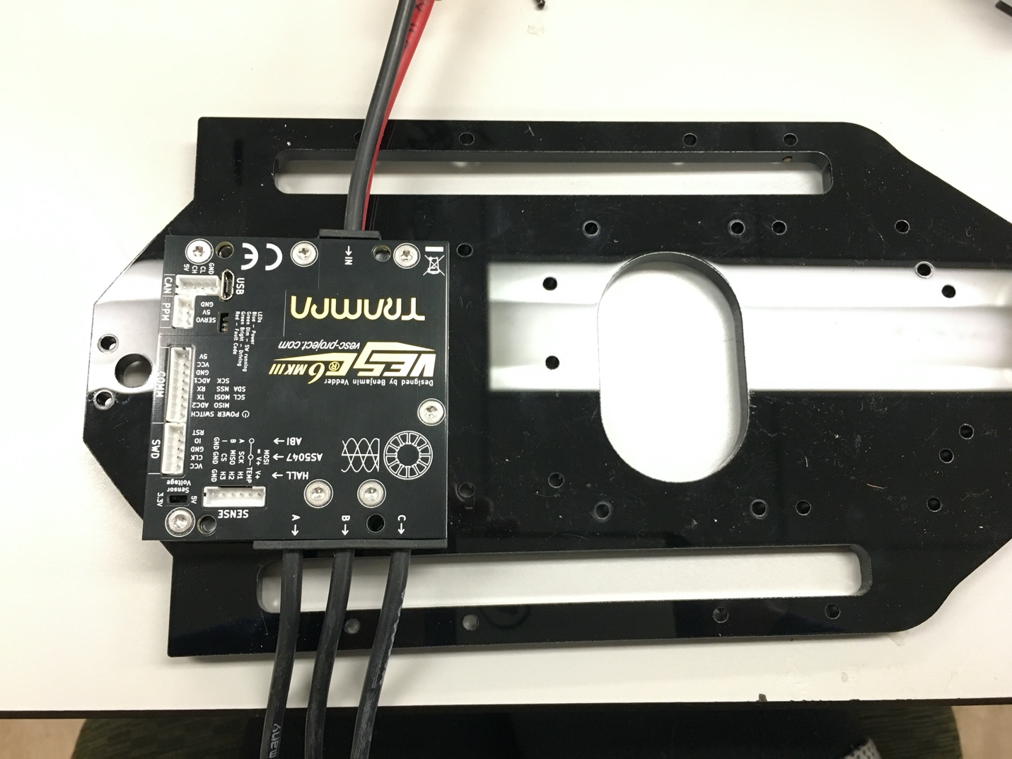

Place the vesc on the acrylic so that the power wires are facing AWAY from you and the yellow, blue, and white cables are facing TOWARDS you. Flip the acrylic and the vesc over and use two M5 screws mounted diagonal from each other to attach the vesc to the acrylic, like shown below.

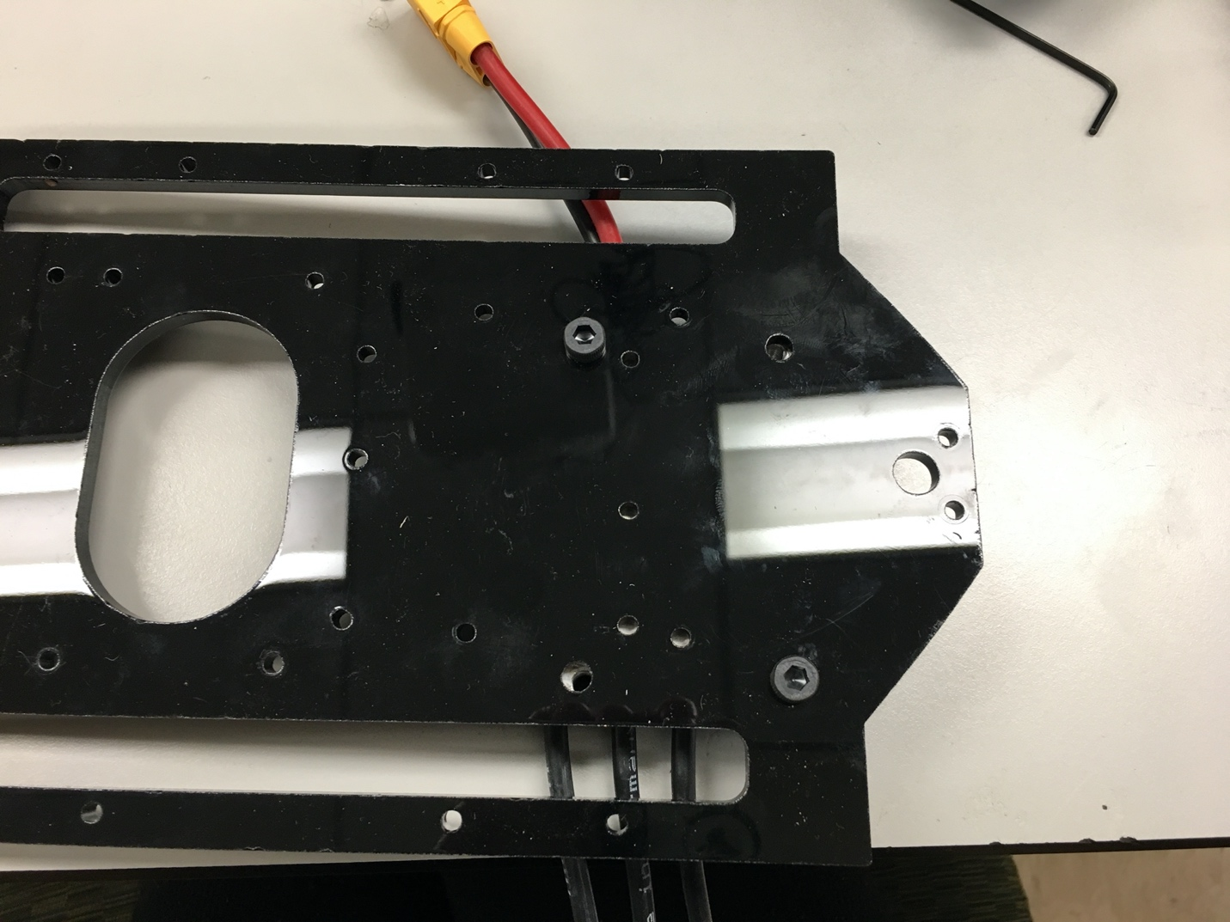

Flip the acrylic back over so the top is facing up and attach the powerboard on top of the vesc. Only three of the powerboard mounting holes are used. Use and M3 8mm then a 25mm M3 FF standoff.

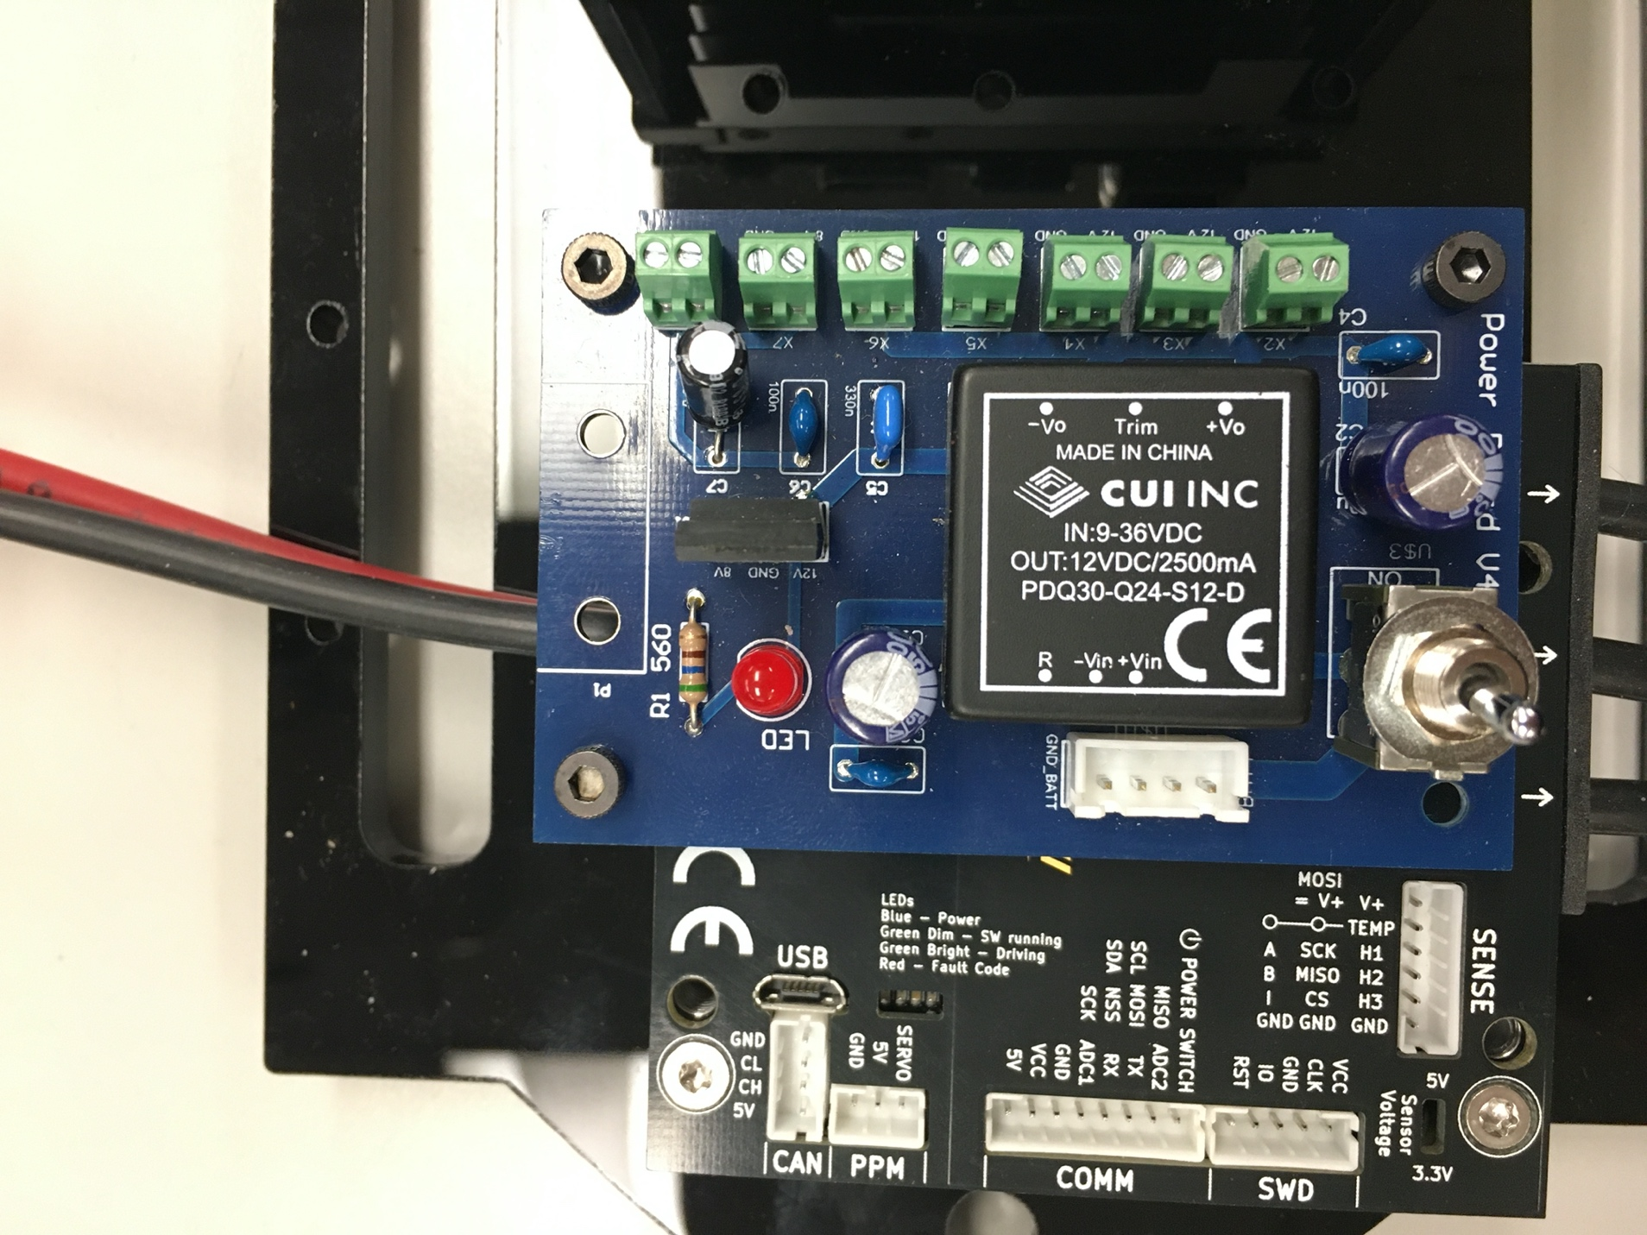

There should be a gap between the powerboard and the vesc.

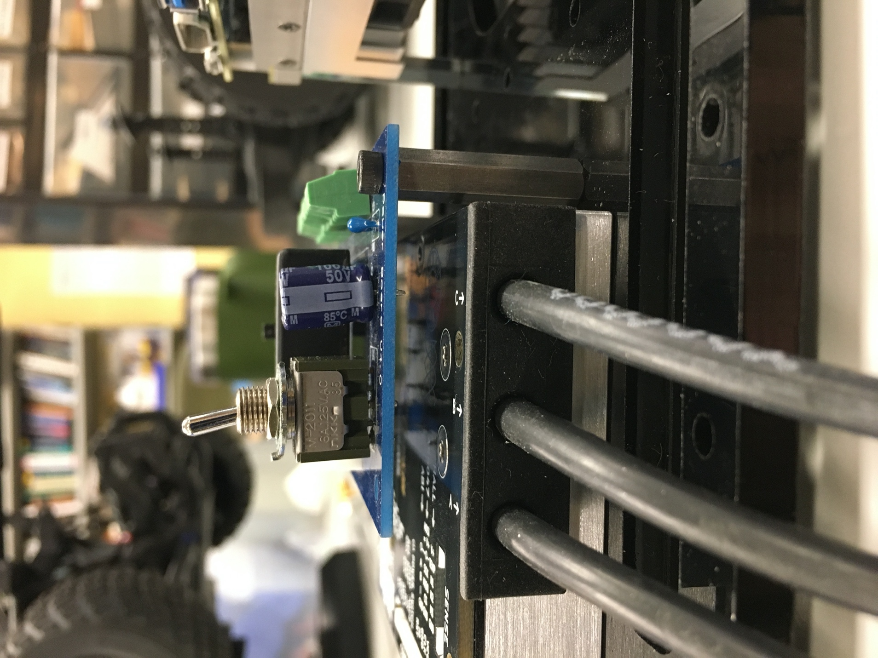

Mount the TX2 so that the USB ports are facing the VESC. Use four screws. The fan should be immediately above the middle opening of the acrylic.

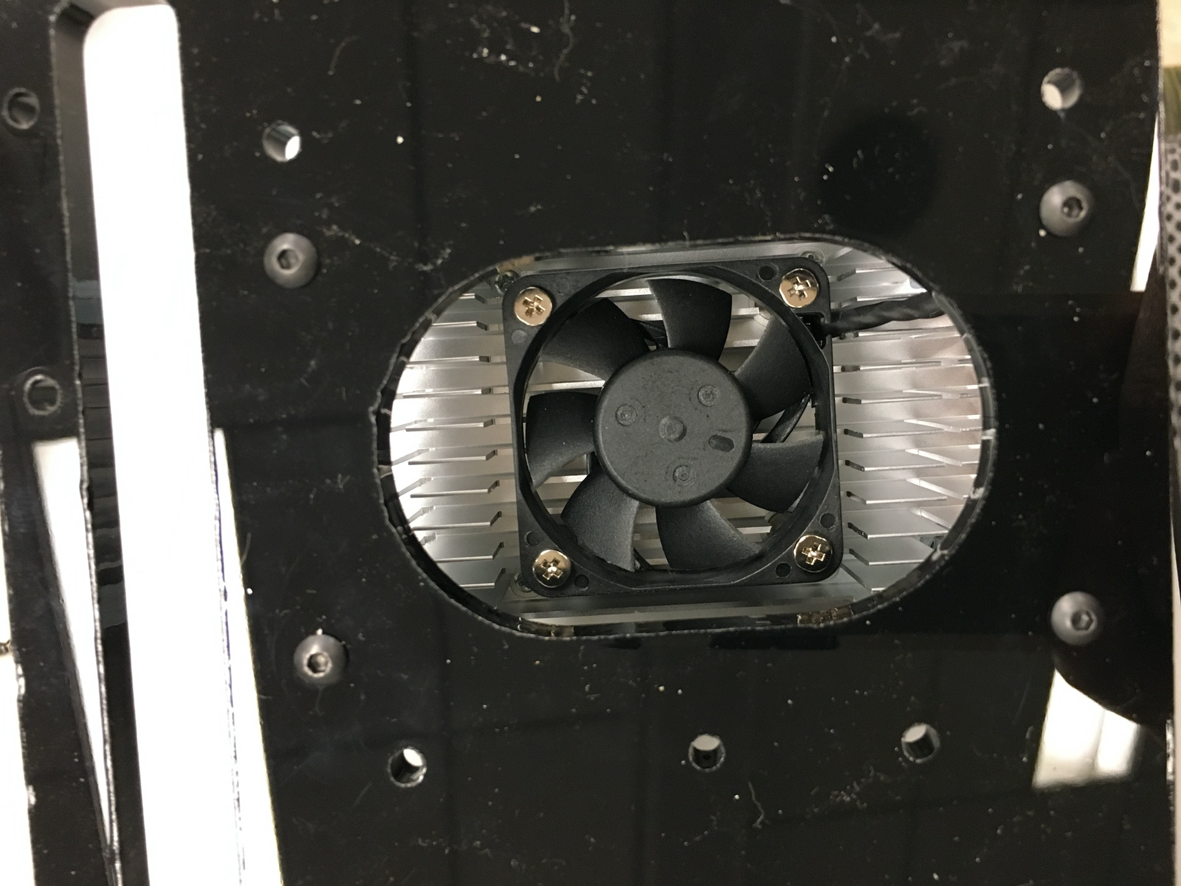

Mount the antenna to the left of the vesc. Most of the components require M3 screws so can also use the screws that you unscrewed from the lower level chassis.

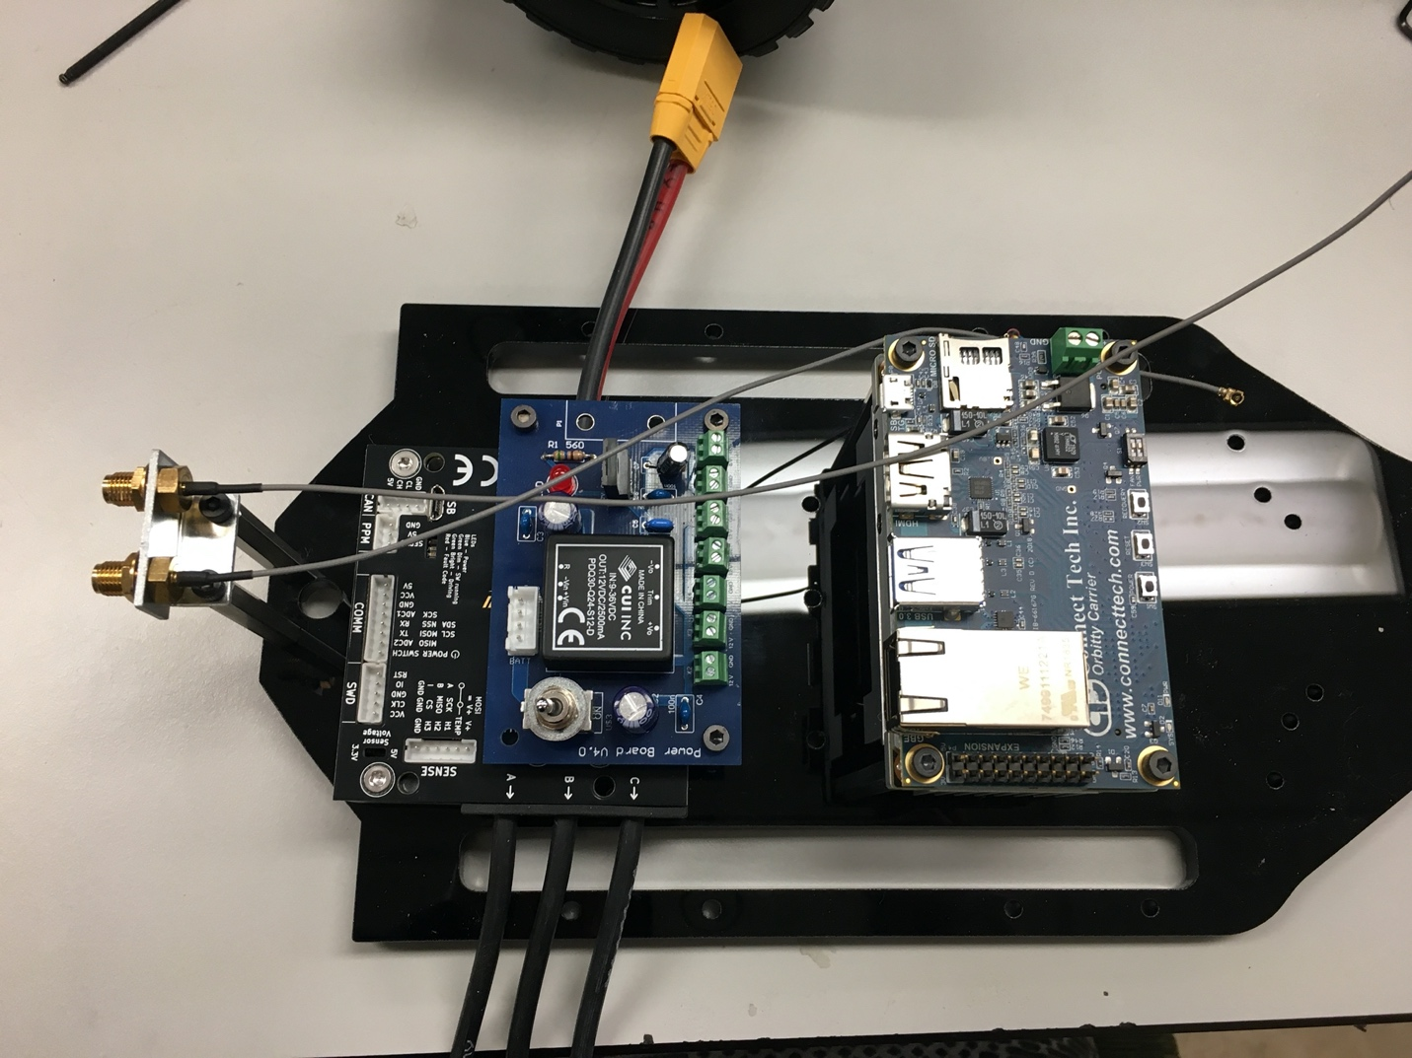

Make sure to also plug the gray antenna wires into the TX2.

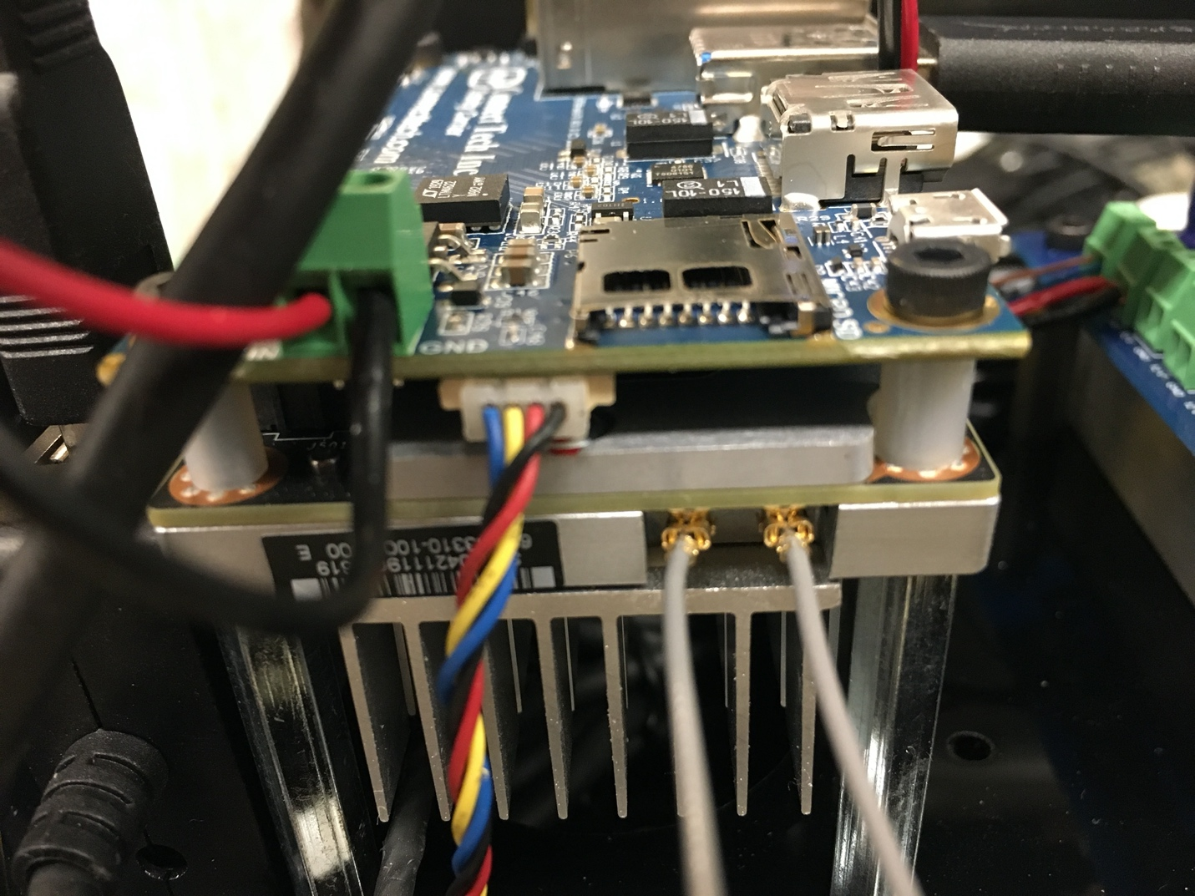

The last component to mount is the lidar. Use four screws to mount from underneath.

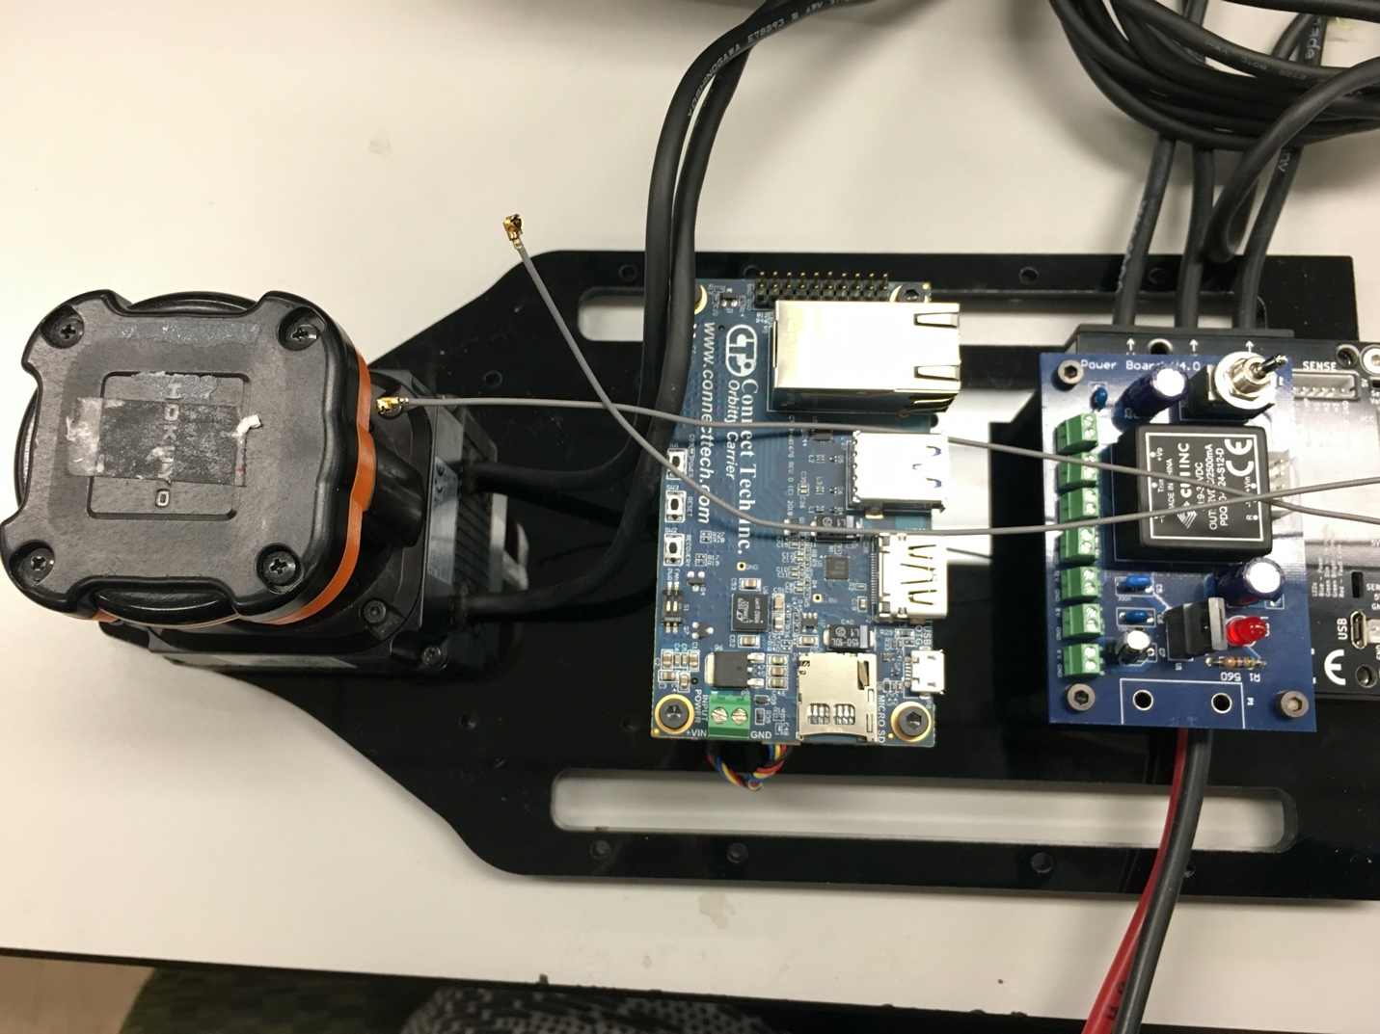

We will need to power the TX2 so connected a power wire and a ground wire from the green terminal of the Orbitty to one of the 12V terminal on the power board.

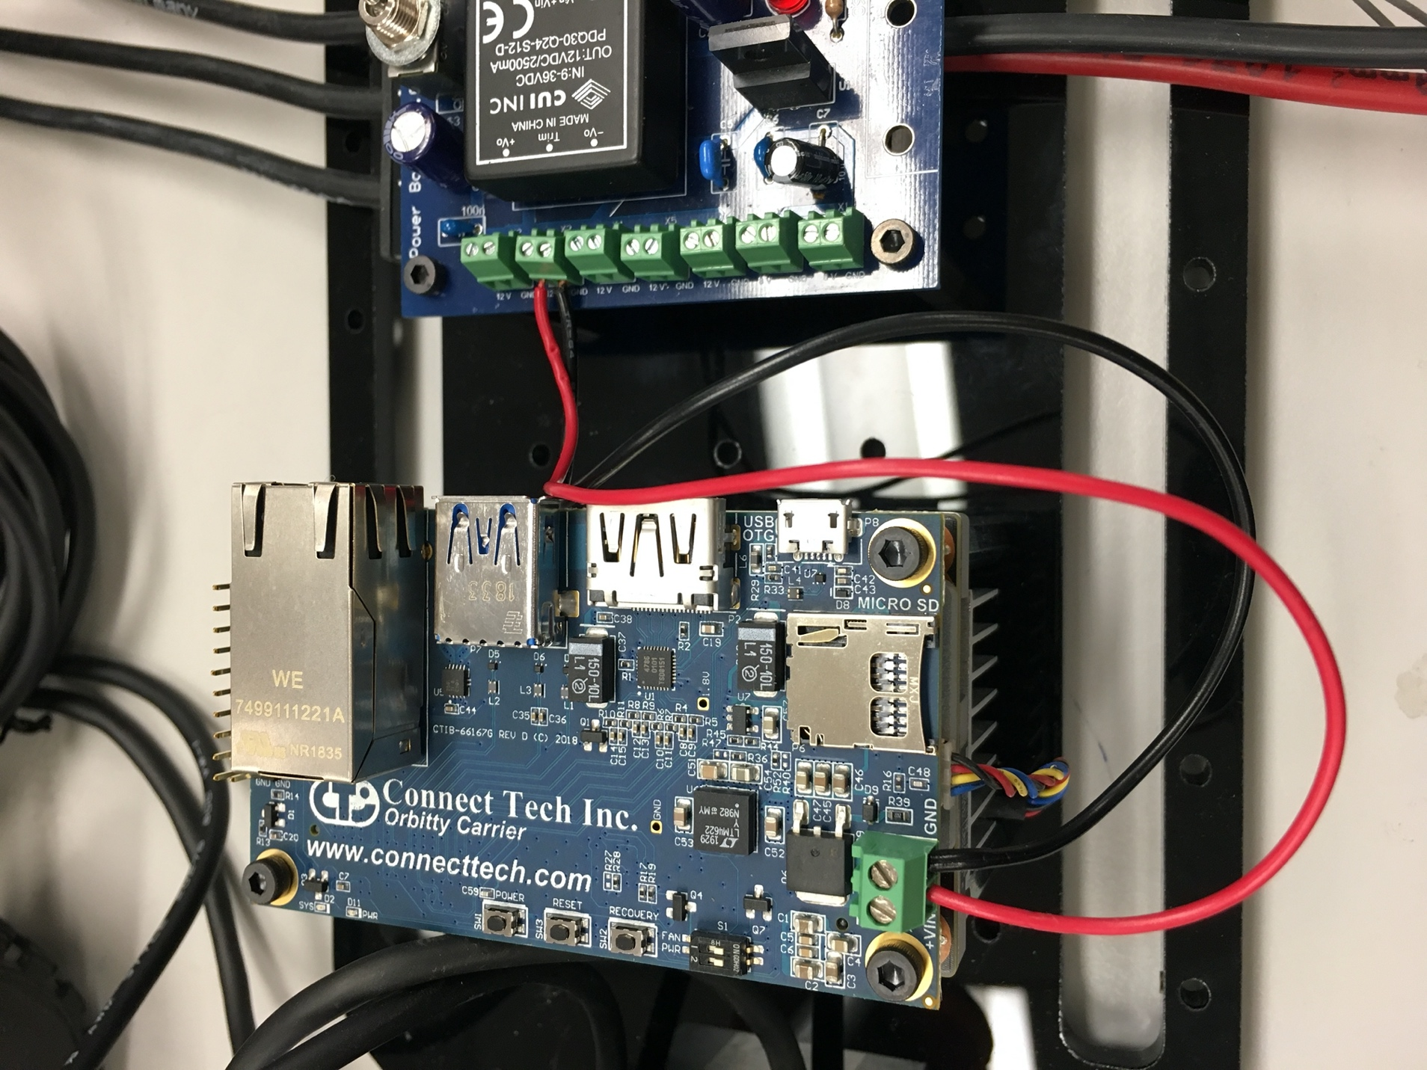

To mount the USB hub, place a piece of double sided tape on the back of the USB hub like so:

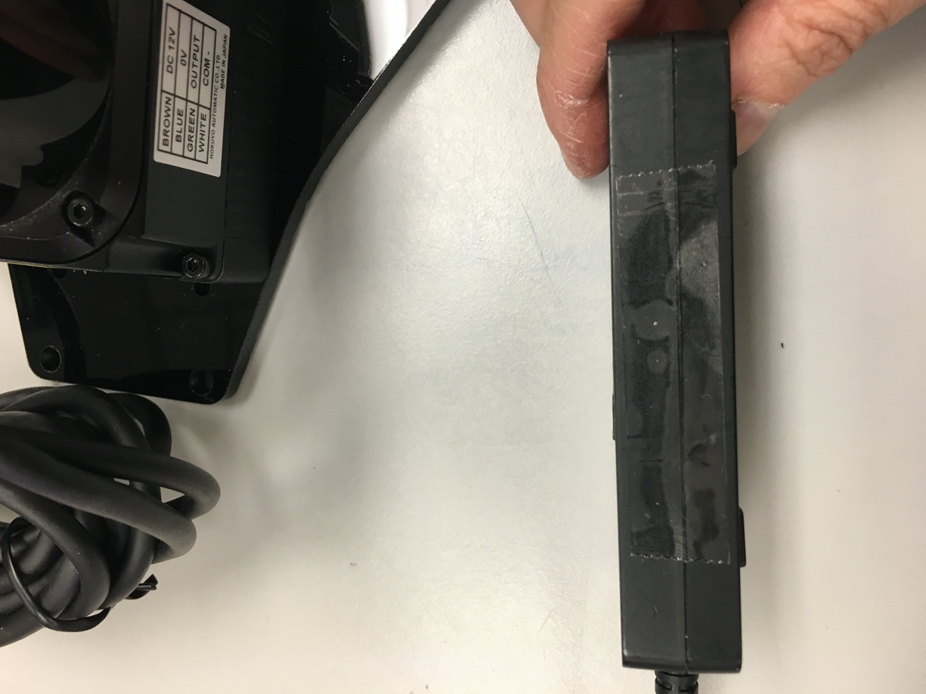

Stick the hub next to the TX2 and press firmly down.

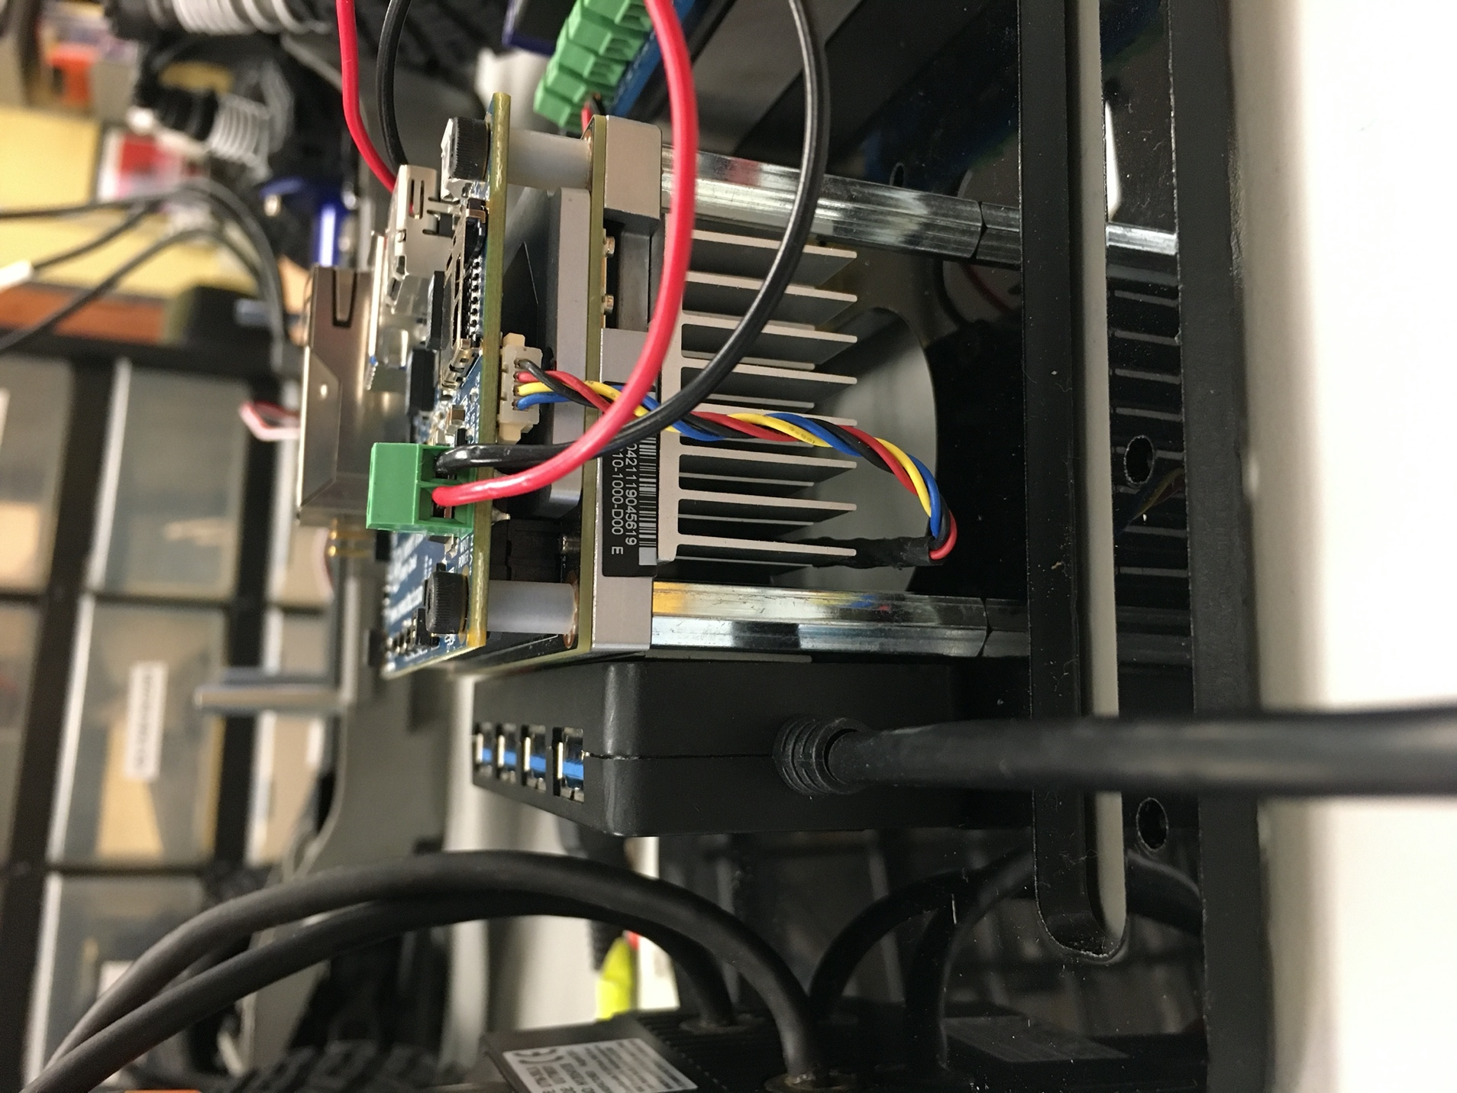

So far, the top view of the upper level chassis should look like this:

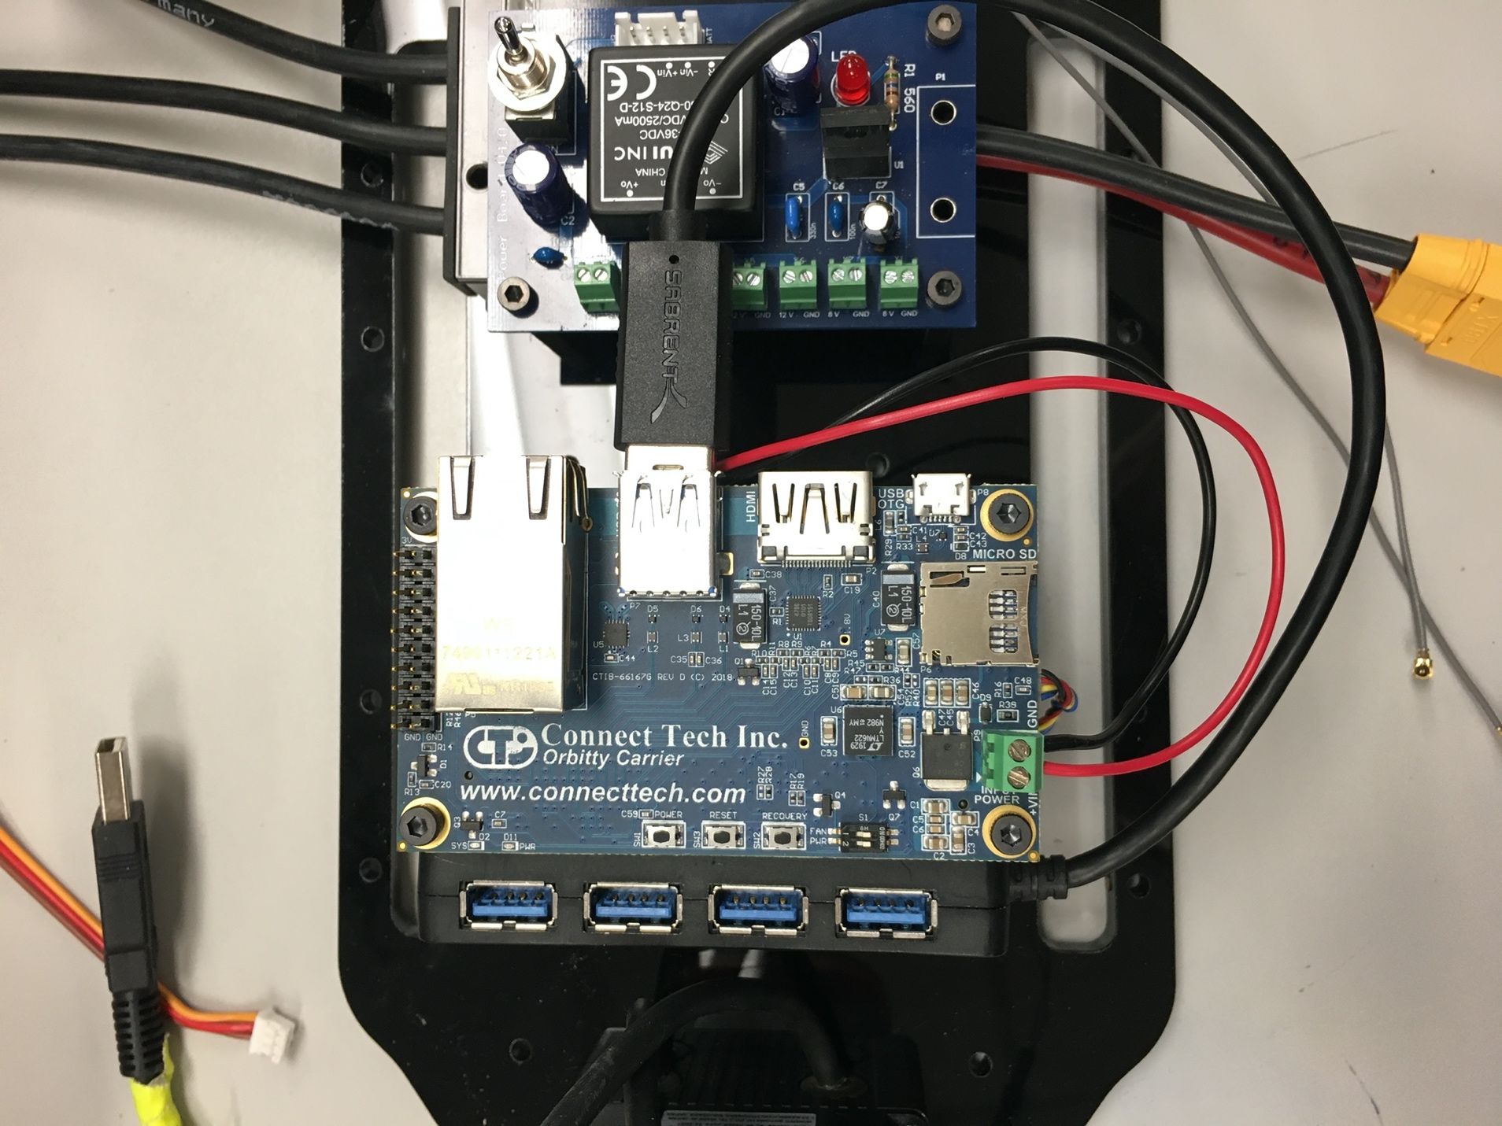

Cable management

Split the two cables of the lidar and loop them under the slots on the acrylic.

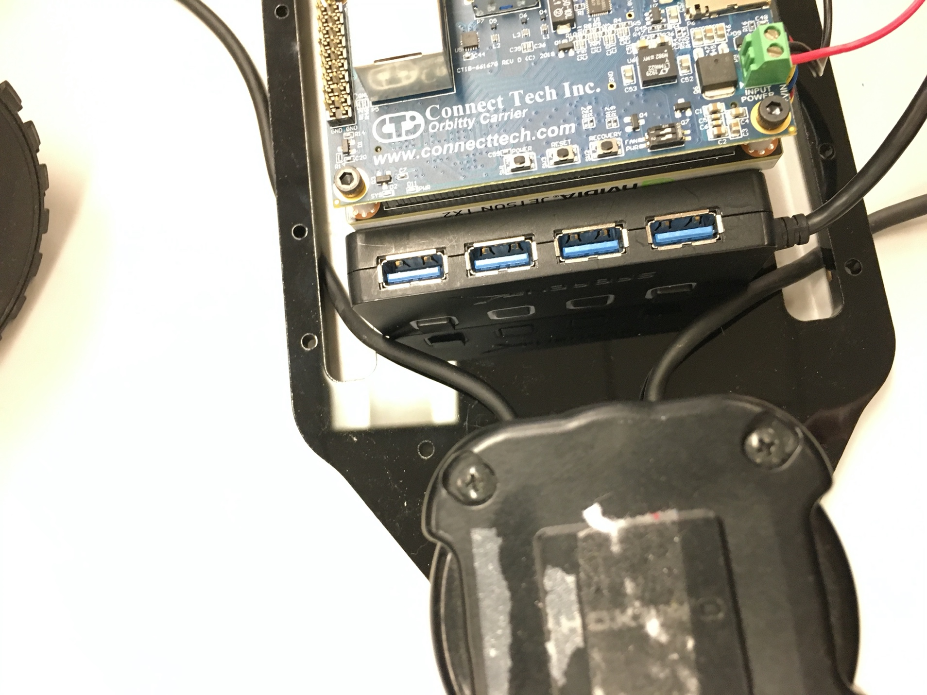

Using a twist tie, rubber band, or zip tie, gather the majority of the cables on each side. For the stripped cable side, insert the brown (power) and blue (ground) wires into one of the 12V terminal blocks on the powerboard. On the USB side, simply plug into one of the ports on the USB hub.

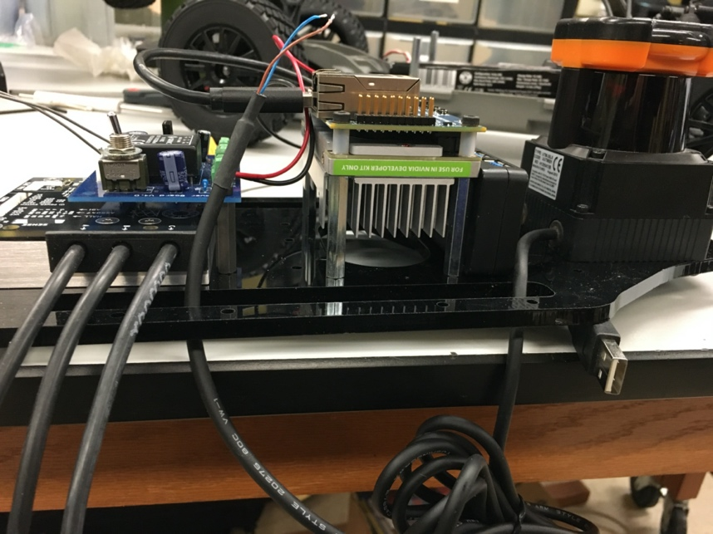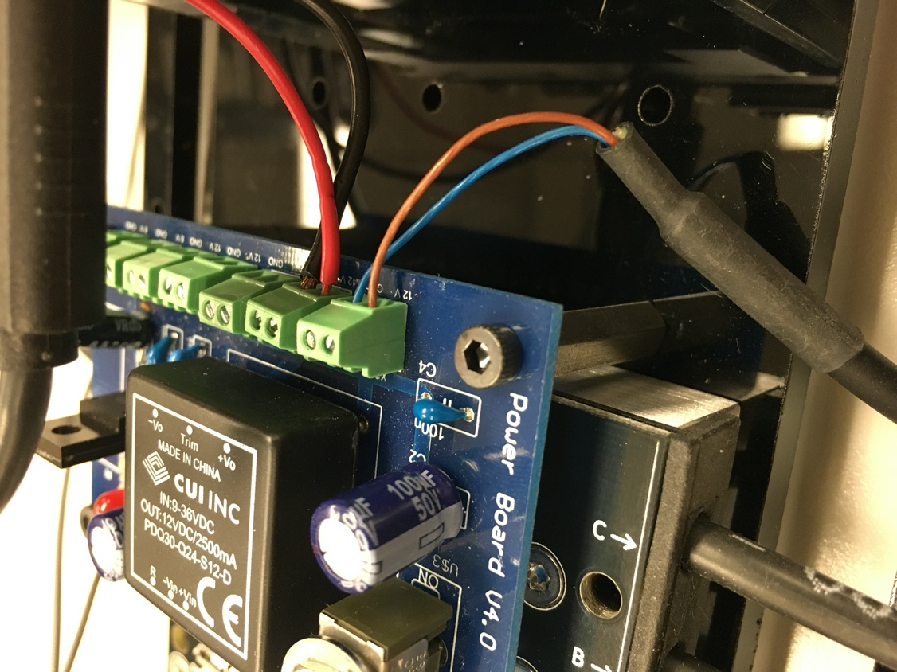

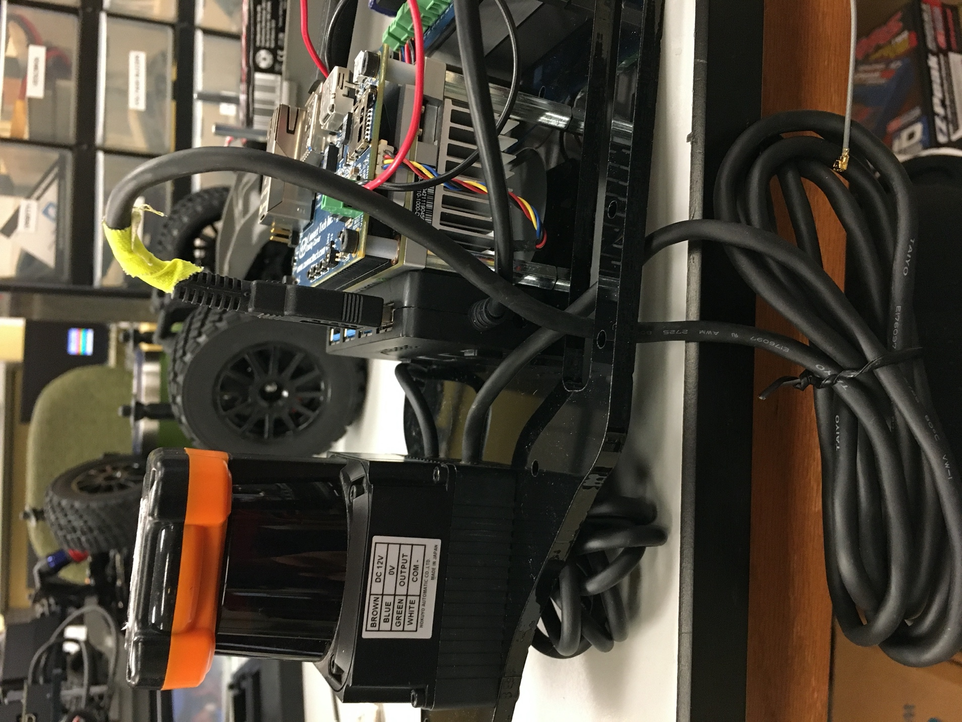

1. Putting it all together!

Now that we have the autonomy elements attached to the upper level chassis, we are going to attach the upper level chassis to the lower level chassis. This part is a bit of an art as we have a lot of cable to manage and things could get unwieldy.

The vesc should be towards the back of the car. Thread the ppm cable from the lower level chassis, through one of the acrylic slot, and lpug it into the ppm slot on the vesc.

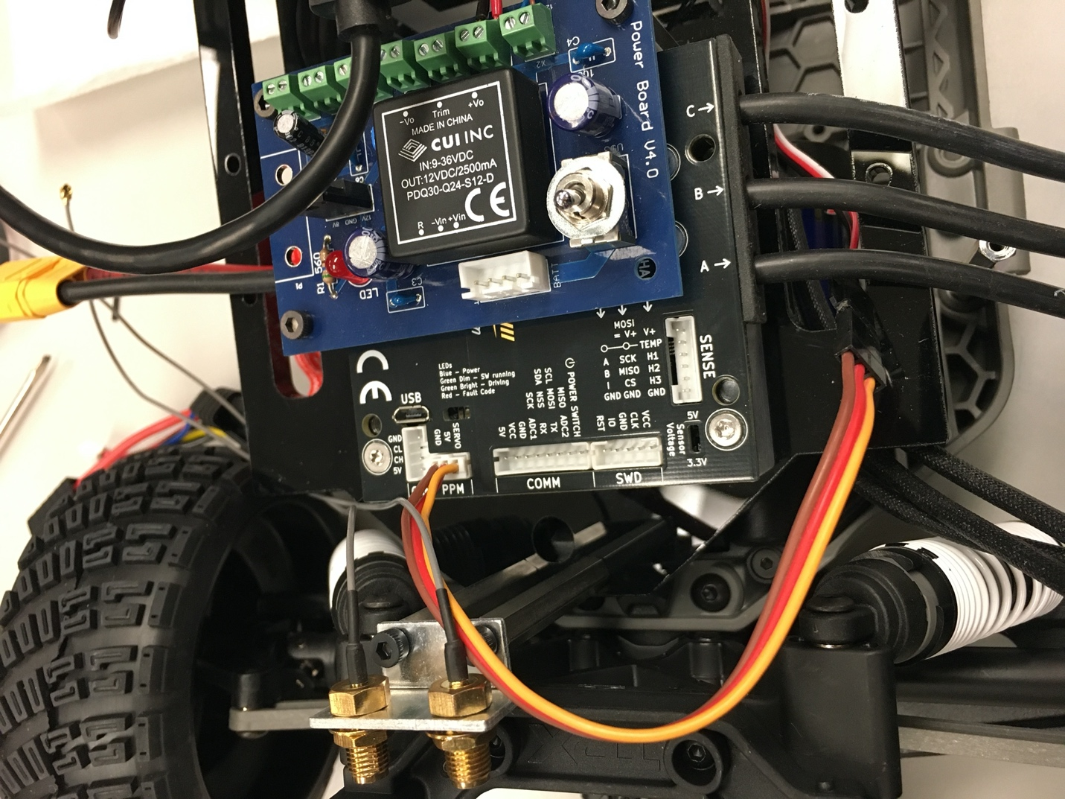

Place the acrylic on top of the standoffs and use M3 screws to attach the acrylic to the standoffs on the lower level chassis.

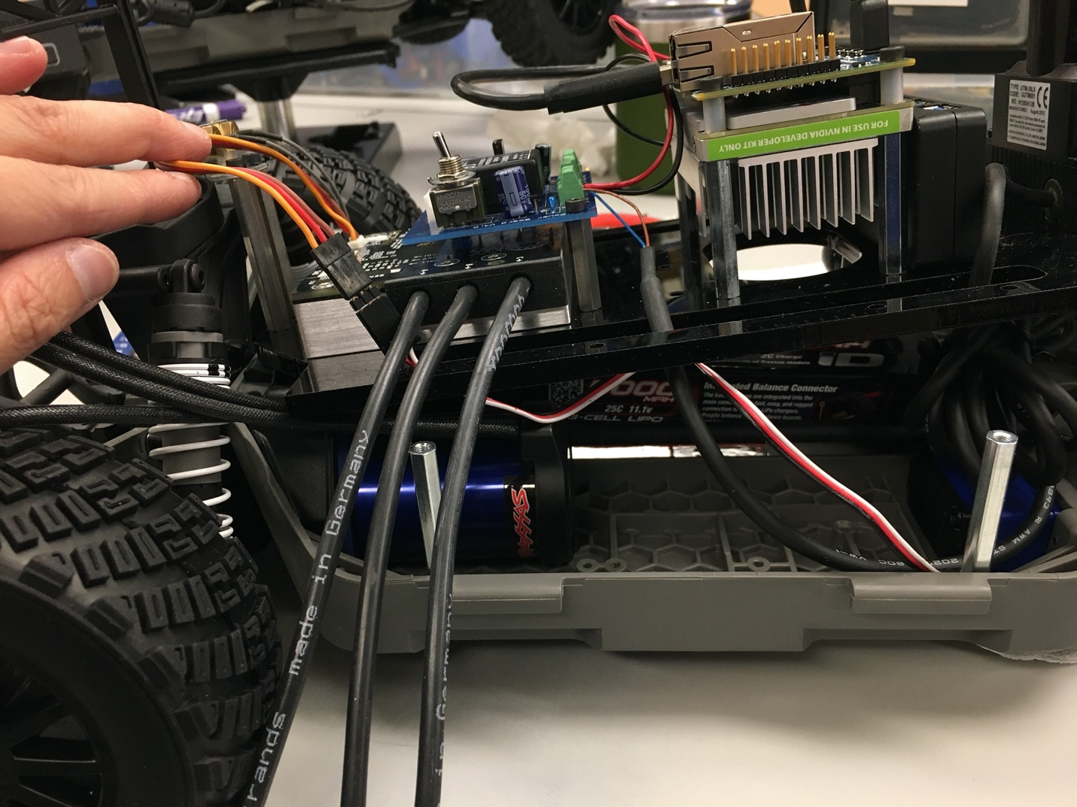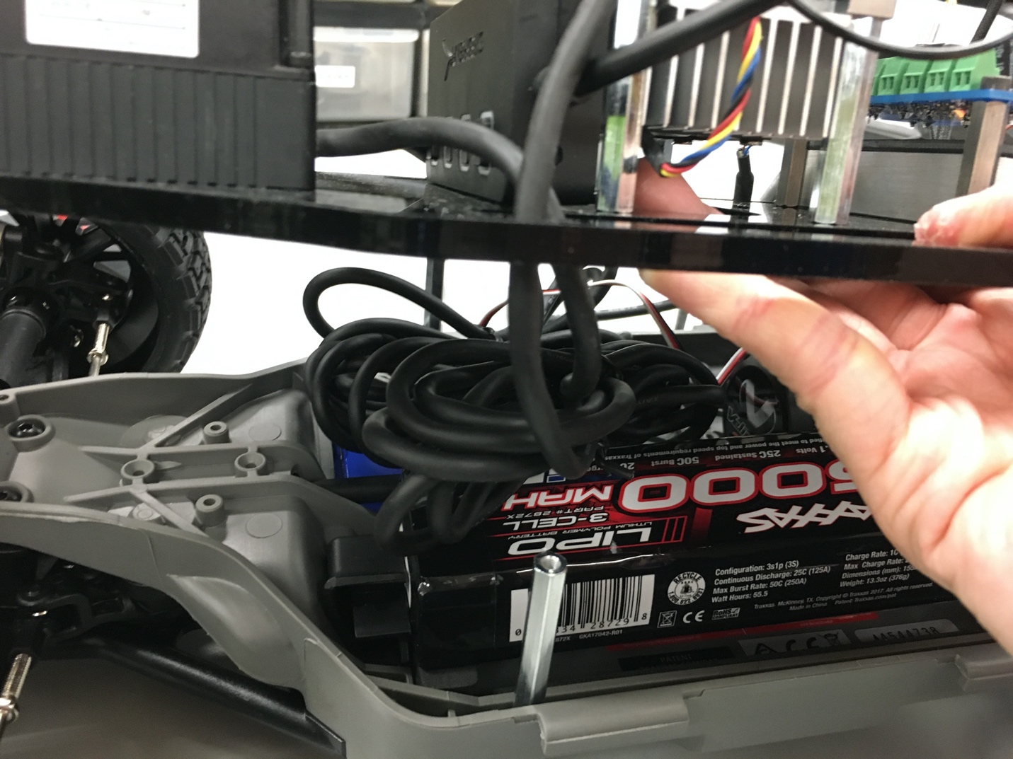

Finally, screw on the antenna and your final vehicle should look like the following:

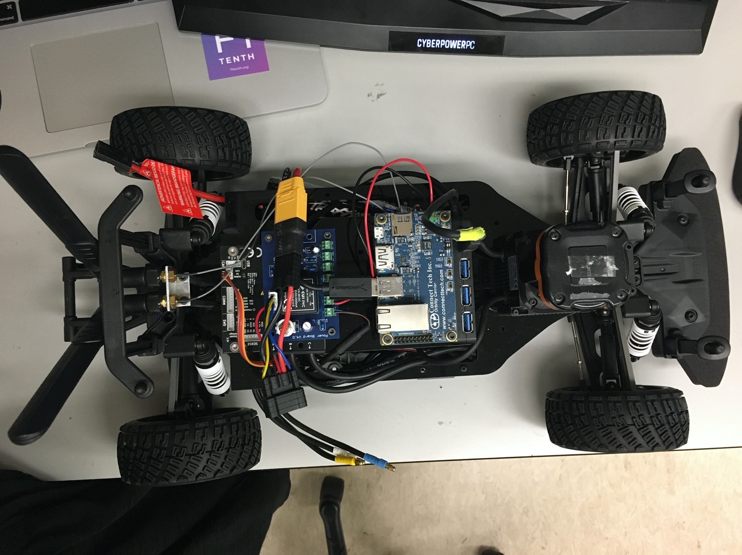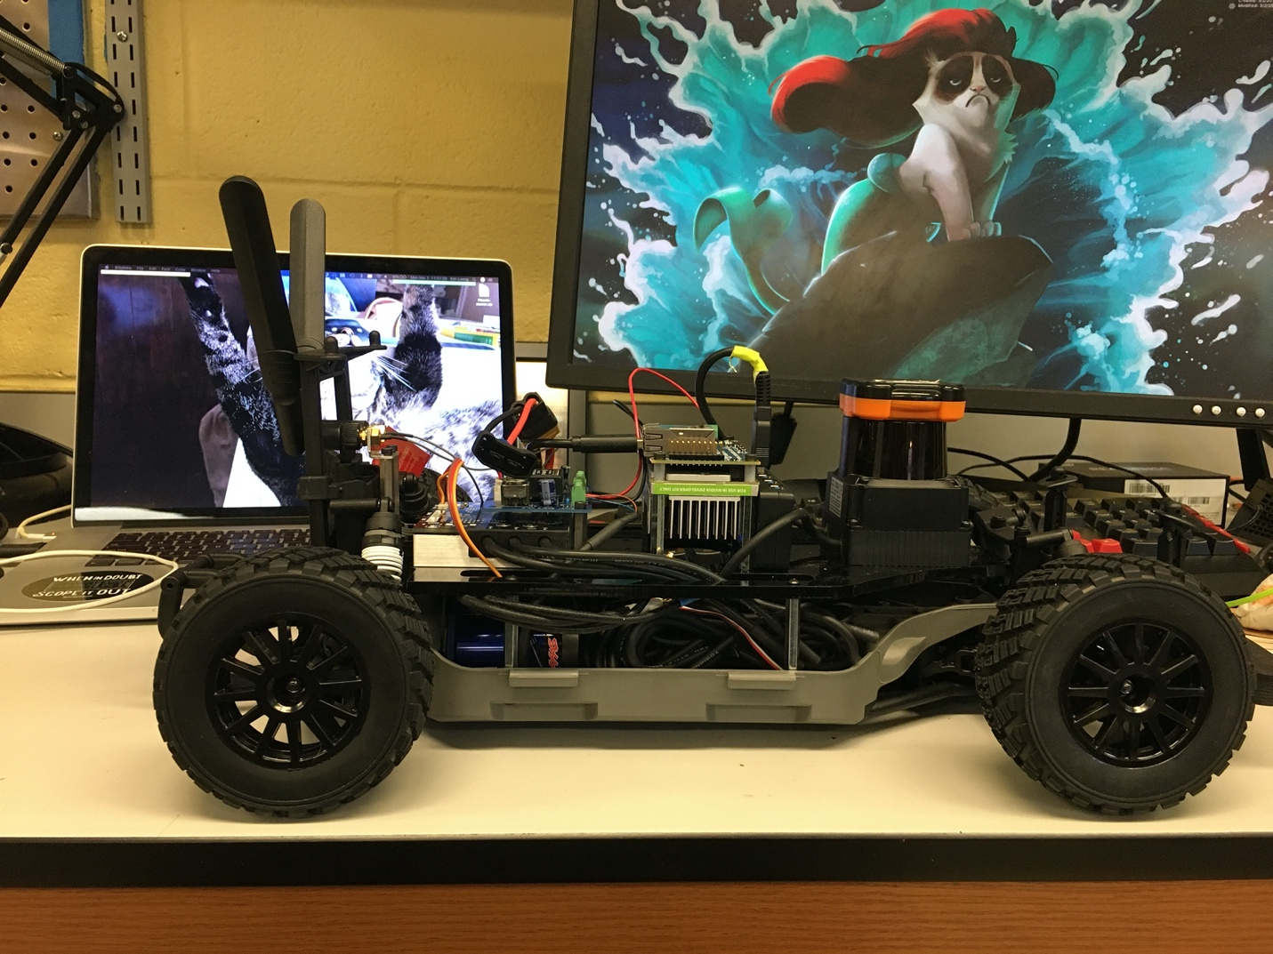

Now we’re ready to start driving! :D